Capgemini L1 Assessment Notes — Testing Concepts
Module 1: Fundamentals of Software Testing
Prepared for V&V Automation Testing • Simple theory + real business examples + assessment practice
This module is important because it explains why software testing is needed, how testing works in a company, how defects affect business, and how testers decide what to test first.
Imagine Capgemini is working for a bank that has developed a mobile banking application. Customers use it to log in, check balances, transfer money, and download statements. Throughout these notes, we will use this banking application as our main business example.
1. Introduction to Software Testing and Definitions
What is software testing?
Software testing is the process of evaluating software to find defects and check whether it meets specified requirements and works as expected.
Simple example: A bank's app allows users to transfer money. A tester checks whether the correct amount reaches the correct account and whether the transaction history is updated.
Important definitions
Term | Simple meaning | Banking app example
Requirement | What the customer or business needs | Users must be able to transfer money
Test case | Steps, data and expected result used to check a feature | Transfer ₹500 and verify the recipient receives ₹500
Test data | Information used during testing | Account number, balance and transfer amount
Expected result | What should happen | ₹500 is transferred successfully
Actual result | What really happens | The app displays success, but the recipient receives nothing
Defect / bug | A flaw in the software | The transaction is marked successful without crediting the recipient
Test execution | Running a test and comparing actual and expected results | Performing the transfer and checking both accounts
Test environment | The setup in which testing occurs | Test server, database, app and test accounts
Test suite | A collection of related test cases | All test cases for money transfers
Test report | A summary of testing progress and results | 90 tests passed, 5 failed and 5 were blocked
Two major types of testing

Manual testing
A tester performs the steps and checks results without relying on a test automation script.
Example: A tester manually logs into the banking app and transfers money.
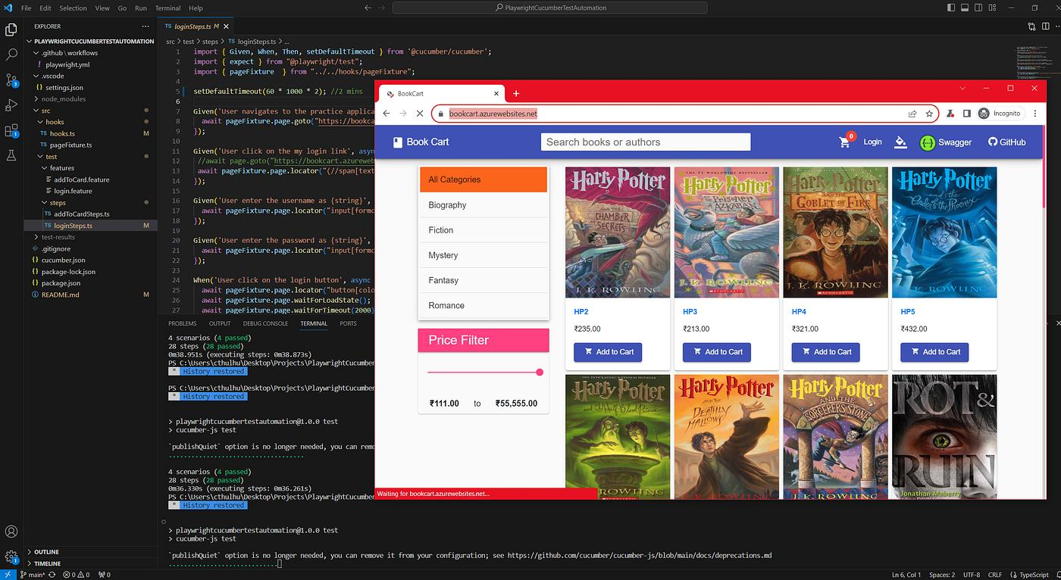
Automation testing
A script performs repeatable checks automatically.
Example: A Playwright script opens the banking website, logs in with test credentials and checks whether the transfer page displays correctly.
Business connection: Manual testing is useful for exploratory checks and features that need human judgment. Automation is useful for repeatable tests, regression testing and frequent releases. Companies often use both.
2. Need for Software Testing
Software testing is needed to:
- Find defects before customers experience them.
- Check that the software meets business requirements.
- Protect customer information and transactions.
- Improve reliability, usability and performance.
- Reduce the cost of fixing defects later.
- Reduce business losses, complaints and reputational damage.
- Check that new changes have not broken existing features.
Real business situation: A bank introduces a new money-transfer feature. Without testing, the app might allow transfers above a customer's limit. Testing helps identify that problem before the feature reaches customers.
Remember: Testing reduces risk; it cannot guarantee that software is completely defect-free.
3. Error vs Defect vs Failure
These three terms are related, but they are not the same.
1. Error
A human mistake made while understanding, designing, coding or configuring software.
Example: A developer misunderstands a requirement and writes the wrong transfer-limit calculation.
2. Defect (Bug)
A flaw in a software work product caused by an error.
Example: The code incorrectly allows a transfer of ₹60,000 when the permitted limit is ₹50,000.
3. Failure
The software behaves incorrectly when it runs.
Example: A customer actually completes a transfer above the permitted limit because the defective code is executed.
The usual relationship is:
Human error → Defect in the software → Possible failure during execution
A defect does not always cause a failure. The affected code may never be executed, or the conditions needed to trigger it may not occur.
Assessment example
A developer mistakenly writes > instead of >= when checking a transaction limit. This is discovered in the code.
- Developer's mistake: Error
- Incorrect condition in the code: Defect
- App rejects a valid transaction at the exact limit: Failure
4. Causes and Cost of Software Defects
Common causes
- Unclear or frequently changing requirements.
- Miscommunication between clients, analysts and developers.
- Incorrect logic or calculations.
- Complex software and integrations.
- Time pressure and insufficient reviews.
- Configuration or environment problems.
- Poorly designed test cases or insufficient testing.
- Incorrect assumptions about how users behave.
Why does the cost increase over time?
A defect found while requirements are being reviewed is usually cheaper to correct than one discovered after deployment, when it may affect customers, data, support teams and other systems.
Example: Incorrect transfer limit
- Requirements stage: The analyst notices that the limit is unclear. The requirement is corrected.
- Development stage: A code review catches the incorrect calculation. The developer fixes it.
- Testing stage: A tester finds the problem, and the team fixes and retests it.
- Production stage: Customers are affected. The company may need an urgent fix, investigation, customer support, transaction reconciliation and a service incident response.
The later discovery can create additional costs, such as fixing related components, retesting, deployment, downtime and loss of customer trust.
L1 takeaway: Early defect prevention and detection are generally more economical than fixing problems after release. There is no single fixed cost ratio that applies to every project.
5. What Does Software Testing Reveal?
Testing provides information about both the software and the risks associated with releasing it.
It can reveal:
- Functional defects: A feature does not work as required.
- Usability issues: The application is difficult to use.
- Performance problems: The application responds slowly under heavy load.
- Security weaknesses: Sensitive information may be exposed.
- Compatibility issues: The application behaves differently across browsers or devices.
- Reliability problems: The application crashes or behaves inconsistently.
- Requirement gaps: The software does not fully satisfy business expectations.
Business example: A banking website works correctly on a laptop but displays the payment button incorrectly on a mobile browser. Compatibility testing helps reveal the issue.
An important point: Testing can show the presence of defects, but it cannot prove that no defects exist.
6. Importance of Testing Early in the SDLC
SDLC stands for Software Development Life Cycle. It is the sequence of activities involved in building and maintaining software.
1
Requirements
Understand what the customer needs
2
Design
Plan the system and its structure
3
Development
Write the code
4
Testing
Check features and find defects
5
Deployment
Release the software
6
Maintenance
Fix issues and improve the product
Testing is not limited to the testing stage. Testers can participate from the requirements stage onward.
Example: Testing a loan application
- Requirements: Check whether the loan eligibility rules are clear.
- Design: Review whether the proposed design covers all eligibility conditions.
- Development: Review code and prepare test cases.
- Testing: Verify eligibility calculations and rejection messages.
- Deployment: Perform appropriate release checks.
- Maintenance: Retest the system after fixes and changes.
Why test early? If a requirement is wrong, correcting the requirement is usually easier than correcting code, retesting multiple modules and fixing production issues.
This approach is often called shift-left testing—moving testing activities earlier in the development process.
7. Testing, Quality and Quality Perception
What is quality?
Software quality is the degree to which software satisfies stated requirements, user needs and relevant quality expectations.
Quality is not only about whether the code works. It can also involve:
- Functionality
- Performance
- Security
- Reliability
- Usability
- Maintainability
- Compatibility
Quality assurance vs quality control vs testing
Term | Meaning | Example
Quality Assurance (QA) | Improving processes to prevent defects | Establishing coding standards and review procedures
Quality Control (QC) | Checking the product against requirements | Inspecting a banking feature for incorrect results
Testing | Evaluating software to find defects and assess quality | Executing test cases for a transfer
Testing is an important part of quality control. QA is broader than testing alone.
What is quality perception?
Quality perception is how users judge the quality of a product based on their experience and expectations.
Example: A banking app may calculate balances correctly, but if it takes 20 seconds to open every screen, users may consider it poor quality.
From a business perspective, the software must work correctly and provide an acceptable user experience.
8. Seven Principles of Software Testing
These are frequently discussed in software testing fundamentals.
1. Testing shows the presence of defects
Testing can find defects, but passing tests do not prove the software has none.
Example: All tested transfer amounts work, but an untested boundary amount still causes a problem.
2. Exhaustive testing is impossible
Testing every possible input, combination and situation is usually impractical.
Example: A banking app has too many possible account balances, transaction amounts, users and device combinations to test every combination.
3. Early testing saves time and money
Start reviewing and testing as early as practical.
Example: Finding an incorrect interest-rate requirement before coding prevents expensive rework.
4. Defects cluster together
A small number of modules often contain a large proportion of the discovered defects.
Example: Repeated issues occur in the payment module because it has complex calculations and integrations.
5. Pesticide paradox
Repeating the same tests may eventually stop finding new defects. Test cases need to be reviewed and expanded.
Example: Always testing successful transfers will not find defects in failed transfers, insufficient balances or invalid account details.
6. Testing is context-dependent
The testing approach depends on the product, its risks and its purpose.
Example: A banking application needs more focus on security and transaction accuracy than a simple informational website.
7. Absence-of-errors fallacy
Software can be nearly defect-free and still fail if it does not meet the user's actual needs.
Example: A banking app works exactly as coded, but customers cannot perform a transfer that the business promised to support.
Memory trick: Presence, Exhaustive, Early, Clustering, Pesticide, Context, Absence.
9. Economics of Testing
Testing uses time, people and tools, so teams must balance testing effort against potential losses from defects.
The goal is not to test everything regardless of cost. The goal is to use resources where testing provides the greatest value and reduces important risks.
Business example: A bank may prioritise tests for money transfers, login security and balance calculations before spending equal effort on a minor visual alignment issue.
A simple decision rule:
- High impact + high likelihood of failure → more testing attention.
- Low impact + low likelihood → lower priority, provided requirements and release criteria are still met.
Testing itself also has costs: test design, environment setup, execution, automation maintenance and defect investigation.
10. How Is Software Testing Conducted?
A simplified testing workflow looks like this:
1
Understand requirements
Determine what the feature must do.
2
Plan testing
Define scope, priorities, resources and schedule.
3
Design test cases
Prepare steps, test data and expected results.
4
Set up the environment
Prepare the application, database, browsers and test accounts.
5
Execute tests
Run manual tests or automated scripts.
6
Report defects
Record evidence, actual results and reproduction steps.
7
Retest and run regression tests
Confirm fixes and check that existing features still work.
8
Report and close testing
Summarise results, unresolved risks and completion status.
Business scenario
A developer fixes a bug in the banking app's login page.
- The tester repeats the failed login test to verify the fix (retesting).
- The tester checks valid login, invalid passwords and account lockout to see whether other features still work (regression testing).
- The tester records the outcome and updates the test report.
Where does automation fit?
Tools such as Playwright can automate repeatable browser tests. For example, a script can open a login page, enter test credentials and verify that the dashboard appears.
Automation supports the testing process; it does not replace requirement analysis, test planning, exploratory testing or human judgment.
11. Software Testing: Past vs Present
Earlier approaches | Modern approaches
Testing often happened after development | Testing is integrated throughout development
More manual and repetitive execution | Manual and automated testing are combined
Releases were often less frequent | Many teams release changes frequently
Defects could be discovered late | Continuous feedback helps find defects earlier
Testing tools were more limited | Teams may use automation, CI/CD and cloud test environments
More focus on whether features worked | Broader focus on security, performance, usability and reliability
These are general trends, not absolute rules. Manual testing remains valuable today, and some projects still use sequential development models.
Business example: An online retailer may release website changes frequently. Automated regression tests help check important functions such as search, cart, checkout and order confirmation after changes are made.
12. Scope of Software Testing
Testing scope means the features, requirements, systems and quality characteristics that will be tested—and, importantly, what will not be tested within the agreed scope.
Example: Online shopping website
In scope:
- Login and logout.
- Product search.
- Adding and removing cart items.
- Applying discount codes.
- Checkout and order confirmation.
Possibly out of scope for a particular test cycle:
- Testing a separate third-party payment provider's internal systems.
- Exhaustively testing every browser version.
- Testing unrelated features that have not changed and are not included in the agreed plan.
Out-of-scope does not mean a feature is permanently untested. It may be covered in another test cycle or by another team.
Factors influencing scope
- Business and user requirements.
- Project deadlines and budget.
- Product complexity.
- Safety, financial or security risks.
- Changes made in the release.
- Supported browsers, devices and operating systems.
- Available people, tools and test environments.
- Legal or regulatory requirements.
- Dependencies on third-party systems.
13. Risk-Based Testing: Project Risks vs Product Risks
Risk-based testing means prioritising testing based on the risks associated with the software and the testing project.
A. Product risk
A risk that the product may fail to meet expectations or cause harm, loss or disruption.
Examples:
- Incorrect bank balance.
- Unauthorised access to an account.
- Failed payments.
- Lost customer orders.
B. Project risk
A risk that affects the ability to complete testing or deliver the project successfully.
Examples:
- Testing is delayed because the test environment is unavailable.
- A key tester is unavailable.
- Required test data arrives late.
- The project has insufficient time or automation infrastructure.
Product risk | Project risk
Concerns the quality or behaviour of the product | Concerns project delivery and execution
Example: Incorrect interest calculation | Example: Test environment unavailable
Addressed through appropriate product testing and other controls | Addressed through planning, resources, schedules and mitigation
How do teams prioritise product risks?
A useful simplified model is:
Risk priority = Likelihood of failure × Impact of failure
This is a conceptual model; companies may use formal scoring methods with additional factors.
For example:
Feature | Likelihood | Impact | Priority
Money transfer | Medium | Very high | High
Login security | Medium | Very high | High
Footer alignment | Low | Low | Low
This helps teams focus on the most important areas first, while still meeting required coverage and release criteria.
14. Need for Independent Testing
Independent testing means testing performed by someone other than the person who created the item being tested, to an appropriate degree of independence.
Why is it useful?
Developers may unintentionally overlook defects because they are familiar with their own implementation or assumptions. A separate tester can approach the feature from a different perspective.
Example: A developer tests a payment feature using a valid account and a successful transaction. An independent tester also checks invalid account numbers, insufficient balances, network interruptions and duplicate submissions.
Levels of independence
- Developer testing: The developer checks their own code.
- Peer testing: Another developer or colleague reviews or tests it.
- Independent testing team: A separate tester or QA team tests the feature.
- External testing: An outside organisation conducts testing, where appropriate.
Independence can improve defect detection, but it does not guarantee defect-free software. Developers should still test their work, and testers should collaborate with developers.
15. Activities in the Fundamental Test Process
A commonly taught fundamental test process has five main activity groups.
1. Test planning and control
Decide what to test, how to test it, who will test it and how progress will be monitored.
Example: Plan which payment scenarios must be tested before the banking app release.
2. Test analysis and design
Identify test conditions, create test cases and define expected results.
Example: Design tests for successful transfers, insufficient balances and transfer-limit boundaries.
3. Test implementation and execution preparation
Prepare test procedures, test data, environments and automated scripts.
Example: Set up test accounts and configure Playwright to run the banking website tests.
4. Test execution
Run tests, compare actual and expected results, record outcomes and report defects.
Example: Execute the transfer tests and report when a transaction exceeds its allowed limit.
5. Evaluating exit criteria and reporting
Check whether agreed completion conditions are met and communicate results and remaining risks.
Example: Report test coverage, pass/fail results, unresolved high-priority defects and release risks.
Important: These activities are not necessarily performed in a strict one-way sequence. Teams may revisit earlier activities when requirements change or defects are discovered.
16. Attributes of a Good Tester
A good tester needs technical skills as well as the right mindset.
- Curiosity: Ask what could go wrong.
- Attention to detail: Notice small inconsistencies.
- Analytical thinking: Understand causes and patterns.
- Communication: Explain defects clearly and respectfully.
- Creativity: Think beyond normal user scenarios.
- Patience: Repeat tests carefully and investigate issues.
- Technical knowledge: Understand the application, test tools and relevant technology.
- Business understanding: Recognise which failures would harm users or the organisation.
- Objectivity: Report results based on evidence rather than assumptions.
- Adaptability: Learn new tools and respond to changing requirements.
Psychology of testing
Testing requires a mindset of questioning and investigation rather than simply proving that the software works.
A tester should:
- Think like a real user.
- Consider unusual and invalid inputs.
- Question assumptions.
- Avoid taking defects personally.
- Work constructively with developers.
- Report both positive and negative findings honestly.
Example: Instead of only checking whether a discount code works, a tester asks: What happens if the code is expired, used twice, entered with spaces or combined with another offer?
Code of ethics
Professional testers should:
- Protect confidential information.
- Respect customer privacy.
- Report results honestly.
- Avoid manipulating test results to hide defects.
- Use systems and data responsibly.
- Communicate professionally.
- Follow laws, organisational policies and authorised testing boundaries.
Business example: A tester finds a security weakness. They should document it and report it through the approved channels, rather than sharing customer information or exploiting the issue beyond authorised testing.
17. Limitations of Software Testing
Testing is essential, but it has limitations.
- Exhaustive testing is impractical: There are too many possible inputs and combinations.
- Testing depends on requirements: Missing or incorrect requirements can cause important scenarios to be overlooked.
- Tests cover only selected conditions: A defect may remain in a scenario that was not tested.
- The test environment may differ from production: Some issues appear only under real-world conditions.
- Testing requires time and resources: Teams must prioritise work.
- Some quality attributes are difficult to measure completely: For example, real-world usability can vary between users.
- Automation has maintenance costs: Scripts can break when interfaces or workflows change.
- Passing tests do not guarantee success: Users may still encounter unknown issues after release.
Business example: A shopping application passes its checkout tests in a test environment. During a major sale, thousands of customers access it simultaneously, revealing a performance problem that did not appear under lighter test loads.
The correct response is not to abandon testing, but to combine suitable test techniques, risk analysis, monitoring, reviews and ongoing improvement.
Capgemini L1 Assessment Notes — Testing Throughout the SDLC
Module 2 • Simple explanations • Real business scenarios • Testing examples • L1 practice
In this module, we will continue using a real-world example: an online banking application where customers log in, check balances, transfer money and download statements.
The main goal is to understand when testing happens, which level or type of testing to use, and how test cases and test data are prepared.
1. Testing Throughout the Software Development Life Cycle
What is SDLC?
The Software Development Life Cycle (SDLC) is a structured process used to plan, design, develop, test, deploy and maintain software.
Testing should not happen only after coding. It should be considered throughout the entire lifecycle.
SDLC phase | Development activity | Testing activity | Business example
Requirements | Understand customer needs | Review requirements and identify test conditions | Confirm the daily transfer limit
Design | Plan system architecture and screens | Review design and prepare test scenarios | Check the transfer flow and error messages
Development | Write code | Code reviews, unit tests and static checks | Verify the transfer calculation
Testing | Build is ready for testing | Execute tests and report defects | Test valid and invalid transfers
Deployment | Release the application | Perform release checks and appropriate smoke tests | Check that login works after deployment
Maintenance | Fix and improve software | Retest fixes and run regression tests | Verify that a login fix has not broken transfers
Why does testing throughout the SDLC matter?
Suppose the bank's requirement says customers can transfer up to ₹50,000 per day.
If the requirement is unclear, a tester can identify the ambiguity before the developer writes the code. That is generally easier than finding the problem after customers start using the feature.
Key term — Shift-left testing: Moving testing activities earlier in the development lifecycle to find problems sooner.
Testing also continues after release because software changes, dependencies are updated and new defects may emerge.
2. SDLC Models in Context
An SDLC model describes how development activities are organised and performed.
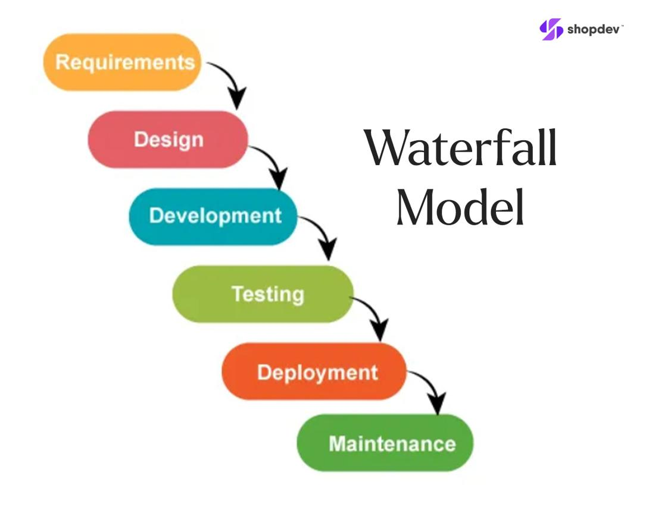
1. Waterfall Model
Development progresses through planned phases in sequence.
Example: A system with stable, well-defined requirements and formal approval stages.
Testing approach: Test planning can begin early, while much of the formal execution may occur after implementation. Late requirement changes can be expensive.
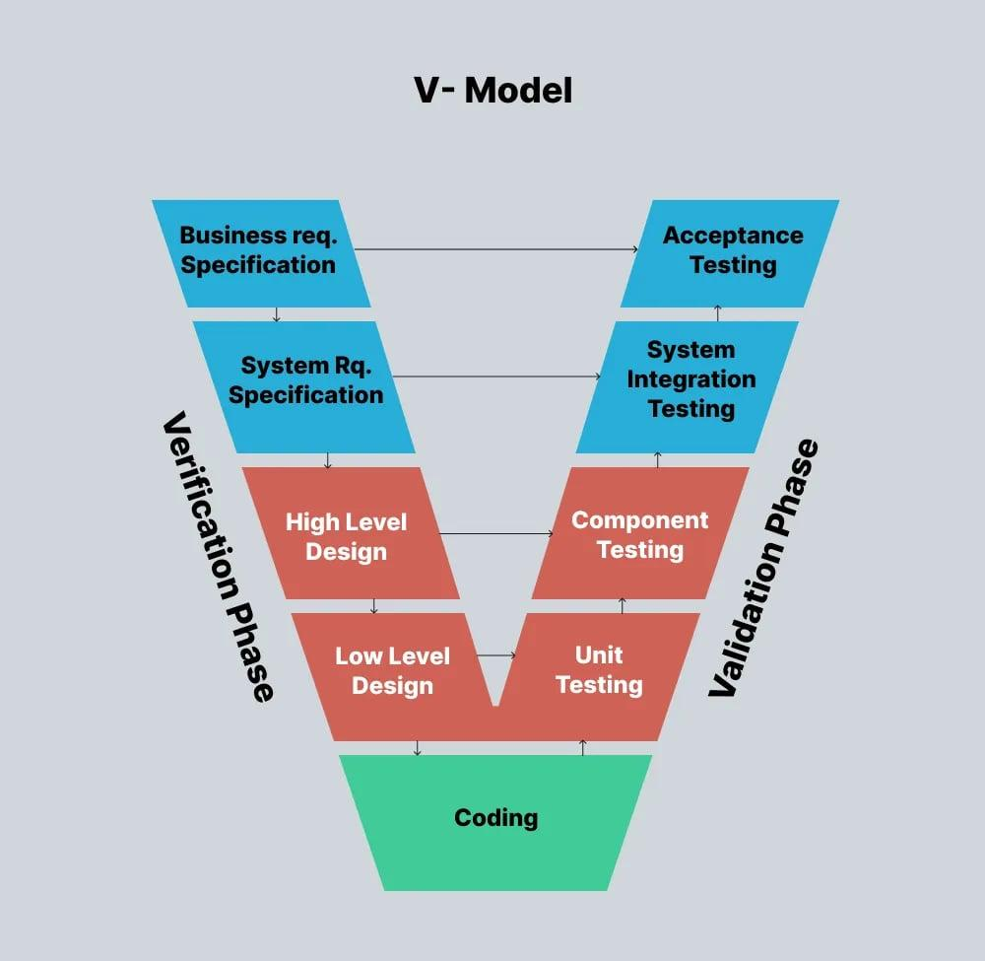
2. V-Model
Development phases are paired with corresponding testing activities. Test planning begins early.
Example: A banking system where requirements, design decisions and acceptance criteria must be traced carefully.
Testing approach: Requirements inform acceptance testing; system design informs system testing; component design informs component testing.
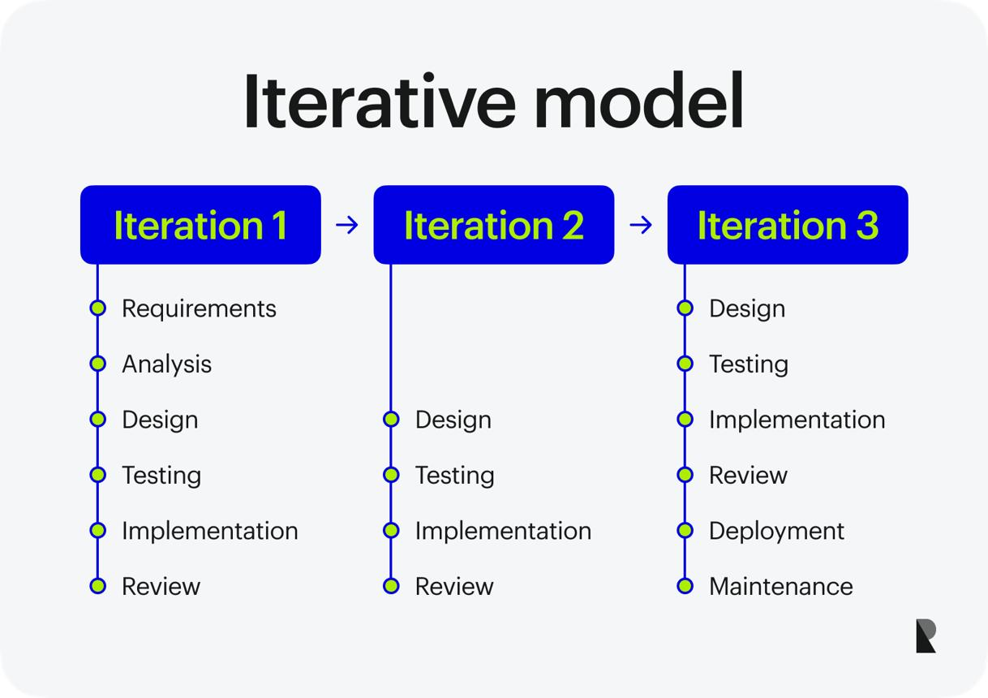
3. Iterative and Incremental Model
Software is developed and improved in repeated cycles or delivered in smaller parts.
Example: A banking app releases balance checking first, then money transfers, followed by bill payments.
Testing approach: Test each increment and check that previous features still work.
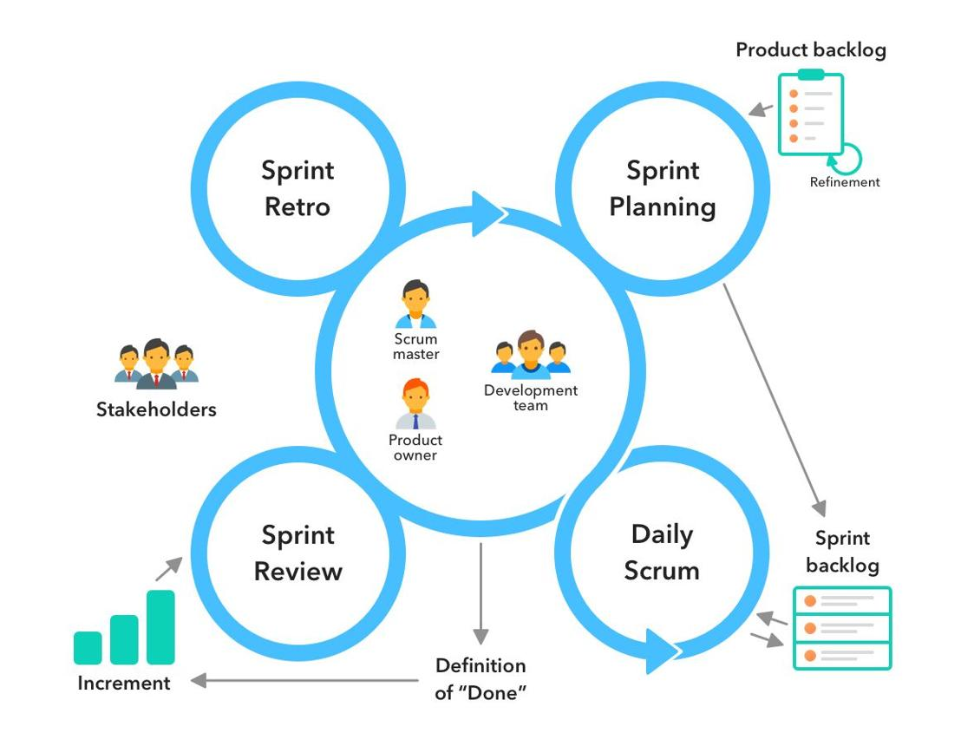
4. Agile Model
Teams work in short iterations or sprints, collaborate frequently and adapt to changing requirements.
Example: A banking team improves the transfer screen every two weeks based on feedback.
Testing approach: Testing occurs throughout each iteration. Automation and regression testing help teams release changes more frequently.
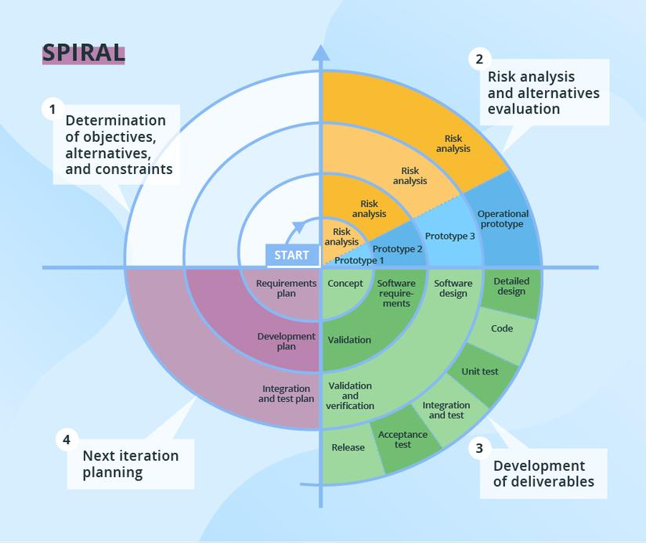
5. Spiral Model
Development proceeds through cycles that emphasise identifying and managing risks.
Example: A complex financial platform with significant security and integration risks.
Testing approach: Testing and evaluation help assess risks in each cycle.
SDLC models — quick comparison
Model | Main idea | Testing emphasis
Waterfall | Sequential phases | Planned phases, often substantial execution later
V-Model | Development and testing activities correspond | Early test planning and traceability
Iterative/Incremental | Build and improve in cycles or increments | Test each increment and protect existing features
Agile | Short iterations and frequent feedback | Continuous collaboration, testing and regression
Spiral | Risk-driven cycles | Identify and evaluate risks throughout development
L1 tip: If a question mentions short sprints, continuous feedback and changing requirements, think Agile. If it mentions corresponding development and test levels in a V-shaped structure, think V-Model.
3. Software Development vs Software Testing
Development and testing have different primary responsibilities, but both contribute to product quality.
Software development | Software testing
Builds the product | Evaluates the product
Implements requirements | Checks whether requirements are satisfied
Writes application code | Designs and executes tests
Fixes implementation defects | Finds, documents and verifies defects
Focuses on creating the intended functionality | Focuses on gathering evidence about quality and risk
Business example
A developer builds the money-transfer function. A tester checks whether:
- A valid transfer succeeds.
- An invalid account is rejected.
- Insufficient funds are handled correctly.
- The transaction limit is enforced.
- The transaction history updates correctly.
The tester is not trying to prove the developer is wrong. Both are working toward a reliable application.
Important: Developers should test their own code too. Testing is not the responsibility of the QA team alone.
4. Test Levels: Component, Integration, System and Acceptance Testing
A test level describes the scope of what is being tested—from a small individual component to the complete product and its acceptance by users.
Remember the order:
Component → Integration → System → Acceptance
1. Component Testing (Unit Testing)
Tests an individual component, function or module in isolation.
Bank example: Check whether a function calculates the available balance correctly.
Usually performed by: Developers, although testers may also perform component-level testing.
2. Integration Testing
Checks whether different components or systems work together correctly.
Bank example: Verify that the transfer service communicates correctly with the account database and transaction-history service.
Main focus: Interfaces, data exchange and interactions between components.
3. System Testing
Tests the integrated application as a whole against its requirements.
Bank example: Test the complete transfer journey—from login through entering the recipient and amount to receiving confirmation.
Main focus: The complete system's behaviour, including relevant functional and non-functional requirements.
4. Acceptance Testing
Evaluates whether the system meets business needs and is acceptable for its intended use.
Bank example: Business representatives or authorised users confirm that the transfer workflow meets their requirements before release.
Main focus: Business needs, acceptance criteria and readiness for use.
A simple real-life analogy: Building a car
- Component: Test the brakes individually.
- Integration: Check how the braking system works with other vehicle systems.
- System: Test the complete car.
- Acceptance: Confirm that the car meets the buyer's agreed requirements.
Test levels — important differences
Level | What is tested? | Typical example
Component | One unit or module | Interest calculation function
Integration | Interactions between units or systems | Payment service and bank API
System | Complete integrated application | End-to-end banking workflow
Acceptance | Fitness for business or user needs | Business validates transfer requirements
Common L1 trap: Integration testing is not the same as system testing. Integration focuses on interactions between components; system testing focuses on the complete integrated system.
5. Test Types
A test type describes the purpose or approach of testing. A test level describes the scope.
5.1 Functional Testing
Functional testing checks what the software does—whether features behave according to requirements.
Examples for a banking application:
- Login with valid credentials.
- Reject invalid passwords.
- Transfer money successfully.
- Prevent transfers when the balance is insufficient.
- Display the correct account balance.
- Generate a transaction statement.
Business situation
The requirement says: "A user must not transfer more money than the available balance."
A tester creates a test with a balance of ₹1,000 and a transfer amount of ₹1,500. The expected result is that the transfer is rejected.
This is functional testing because the tester is checking the application's required behaviour.
5.2 Non-functional Testing
Non-functional testing evaluates how well the software works—its performance, usability, security, reliability and other quality characteristics.
Type | What it checks | Business example
Performance testing | Speed, responsiveness and behaviour under load | Can the banking app handle thousands of simultaneous users?
Load testing | Behaviour under expected workload | Does the app respond properly during normal peak-hour traffic?
Stress testing | Behaviour beyond normal operating limits | What happens when traffic exceeds the system's intended capacity?
Security testing | Protection against unauthorised access and vulnerabilities | Can one customer access another customer's account?
Usability testing | Ease of use | Can customers understand how to add a recipient?
Compatibility testing | Behaviour across supported devices and browsers | Does the website work correctly in Chrome and Edge?
Reliability testing | Consistent operation over time | Does the service remain stable during extended use?
Accessibility testing | Usability by people with different abilities | Can keyboard and screen-reader users navigate the transfer form?
Business example
The transfer function works correctly when tested with one user. However, it becomes very slow when many users use it simultaneously.
- Correctness of the transfer function: Functional testing
- Response time under load: Non-functional performance testing
A product needs both functional and non-functional testing.
5.3 White-box Testing
White-box testing examines the internal structure, logic or code of the software.
The tester needs an understanding of how the code is structured.
Example:
if (balance >= amount) {
transferMoney();
} else {
showInsufficientBalance();
}
A tester checks both paths:
- balance >= amount is true.
- balance >= amount is false.
This is an example of checking decision branches in code.
Common white-box techniques
- Statement coverage: Have the executable statements been run?
- Branch coverage: Have the possible decision outcomes been exercised?
- Path testing: Have selected execution paths been tested?
White-box testing is often performed by developers, but other technical testers may also do it.
Black-box vs White-box Testing
Black-box testing | White-box testing
Focuses on external behaviour | Focuses on internal code or structure
Internal implementation need not be known | Internal implementation is examined
Uses requirements and inputs/outputs | Uses code logic, branches and paths
Example: Verify an invalid password is rejected | Example: Check both branches of the password-validation condition
Memory trick: Black box = behaviour; White box = internal logic.
5.4 Smoke Testing
Smoke testing is a broad, initial check of critical functionality to determine whether a build is stable enough for more detailed testing.
Banking app example: After a new build is installed, the tester checks whether:
- The application launches.
- Login works.
- The dashboard loads.
- Account details are displayed.
- The transfer page opens.
If these basic functions fail, the build may be rejected for further testing until the major issues are fixed.
Business value: It avoids spending hours running detailed tests on a build that is fundamentally broken.
5.5 Sanity Testing
Sanity testing is a focused check that a particular change or fix works as expected and has not caused an obvious issue in the affected area.
Example: The developer fixes a bug where the transfer limit is calculated incorrectly. The tester checks the corrected limit and a few closely related scenarios.
Smoke vs Sanity Testing
Smoke testing | Sanity testing
Broad and shallow | Narrow and focused
Checks critical features of a new build | Checks a specific change or affected area
Helps decide whether to proceed with deeper testing | Helps decide whether the targeted fix or change is behaving correctly
Example: Check login, dashboard and transfer page after a new build | Example: Check the corrected transfer-limit calculation
Terminology can vary between organisations, so follow the team's defined process when working on a project.
5.6 Change-related Testing
Change-related testing is performed after modifications to software. Two key forms are retesting and regression testing.
A. Retesting (Confirmation Testing)
Retesting verifies whether a previously reported defect has been fixed.
Example: A transfer failed when the amount was exactly ₹10,000 because of a coding error. After the fix, the tester repeats that test to confirm the defect is resolved.
B. Regression Testing
Regression testing checks whether a change has unintentionally affected existing functionality.
Example: After the transfer-limit fix, the tester also checks:
- Normal transfers.
- Transfers below the limit.
- Transfers above the limit.
- Transaction history.
- Account balance updates.
Retesting vs Regression Testing
Retesting | Regression testing
Checks a specific previously failed test | Checks for unintended side effects of a change
Focuses on the reported defect | Focuses on potentially affected existing functionality
Usually targets the fix directly | May cover multiple related areas or a broader suite
Assessment shortcut: "Did the original bug get fixed?" = Retesting. "Did the change break anything else?" = Regression testing.
6. Test Types and Test Levels — How They Work Together
This is an important concept because a test level and a test type answer two different questions.
- Test level: What scope are we testing?
- Test type: What are we checking or trying to achieve?
For example, performance testing is a test type. It can be performed at different levels depending on the goal and test setup.
Scenario | Test level | Test type
Check a balance-calculation function | Component | Functional, white-box or black-box depending on the approach
Check communication between a payment service and database | Integration | Functional
Check complete login and transfer workflow | System | Functional
Check response time of the complete banking app | System | Non-functional — performance
Business representative validates the transfer workflow | Acceptance | Functional / business acceptance
Check code branches inside the transfer calculation | Component | White-box
A combined business example
Suppose a bank adds a new payment feature.
- The developer tests the payment-calculation function. This is component testing.
- The team verifies communication between the payment service and account service. This is integration testing.
- The QA team checks the full payment journey. This is system testing.
- Business users confirm that the feature satisfies their requirements. This is acceptance testing.
- The team also checks whether the payment journey performs well under heavy traffic. This is non-functional performance testing.
Notice that the fifth activity is a type of testing that can be carried out alongside testing at the relevant level.
7. Maintenance Testing, Triggers and Impact Analysis
What is maintenance testing?
Maintenance testing is testing performed when existing software is modified, migrated, corrected or otherwise changed after its initial release.
Software requires maintenance because business rules change, defects are discovered, technology changes and new features are introduced.
What triggers maintenance testing?

1. Corrective maintenance
Fixing a defect.
Example: Correct an incorrect account balance shown after a transfer.

2. Perfective maintenance
Improving existing functionality, usability or performance.
Example: Improve the transaction-history page so customers can filter transactions more easily.

3. Adaptive maintenance
Adapting the software to a changed environment.
Example: Update the banking website to support a newly required browser version or a changed external API.
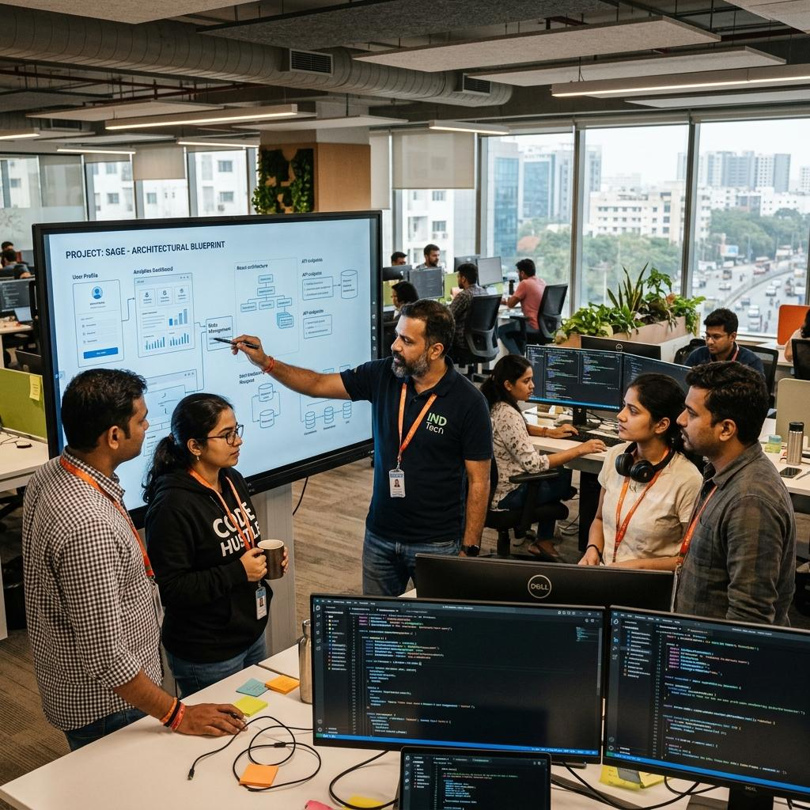
4. Preventive maintenance
Making changes intended to reduce future problems or improve maintainability.
Example: Refactor complicated transaction code to make future changes safer.
These categories describe common maintenance purposes; a single change may serve more than one purpose.
What is impact analysis?
Impact analysis identifies which parts of the system, requirements, tests and dependencies may be affected by a proposed change.
Example: The bank changes its transfer limit from ₹50,000 to ₹75,000.
The tester should investigate whether the change affects:
- Transfer validation.
- User-interface messages.
- Daily-limit calculations.
- API validation.
- Transaction reports.
- Automated test data and assertions.
- Existing regression tests.
The team can then select the appropriate tests rather than blindly rerunning only the test that triggered the change.
Why is impact analysis useful?
- Finds potentially affected components.
- Helps choose regression test cases.
- Reduces the chance of missing side effects.
- Helps estimate the effort required for testing.
- Supports release decisions.
L1 takeaway: A software change should lead to an impact assessment, suitable retesting and regression testing based on the affected areas and associated risks.
8. Test Case Terminologies
A test case defines a specific condition to verify, including the inputs, actions and expected results needed to evaluate the software.
Consider the requirement: "A customer cannot transfer more money than their available balance."
Here is a sample test case.
TC-TR-004
Sample test case
Title: Reject transfer when the amount exceeds the available balance
Preconditions
- Customer has logged in successfully.
- Available balance is ₹1,000.
- The test account is active.
Test data
- Transfer amount: ₹1,500.
Steps
  - Open the transfer page.
  - Enter a valid recipient.
  - Enter ₹1,500 as the transfer amount.
  - Submit the transfer.
Expected result
The transfer is rejected, an appropriate message is displayed, and no money is deducted.
Actual result
Recorded after executing the test. For example, the application unexpectedly processes the transfer.
Status
Pass or fail, based on the comparison of actual and expected results.
Important test case terms
Term | Meaning | Example
Test scenario | A high-level situation to verify | Validate money transfers
Test condition | A specific aspect to check | Reject transfers above the balance
Test case | Defined inputs, steps and expected results | Transfer ₹1,500 when the balance is ₹1,000
Test data | Values used in the test | Balance ₹1,000; transfer ₹1,500
Preconditions | What must be true before testing | User is logged in
Test steps | Actions performed | Enter amount and submit
Expected result | Required outcome | Transfer is rejected
Actual result | Observed outcome | What the application actually did
Postconditions | State expected after the test | Balance remains unchanged
Test suite | A collection of test cases | All transfer-related tests
Test execution | Running a test case | Submit the transfer and inspect the result
Test log | Record of execution activities and outcomes | Timestamp, result and execution notes
Defect report | Details of a discovered problem | Incorrect transfer accepted
Test scenario vs test case
- Scenario: Check login functionality.
- Test cases: Login with valid credentials, invalid password, blank fields and a locked account.
A scenario describes a broader area; individual test cases check specific conditions within it.
Positive vs Negative Testing
Positive testing checks whether software works with valid inputs.
Example: Transfer ₹500 when the account has sufficient funds.
Negative testing checks how software handles invalid inputs or conditions.
Example: Attempt a transfer with an invalid recipient or insufficient funds.
Both are necessary because software must handle valid usage and reject invalid or unsafe operations correctly.
Boundary Value Analysis
Boundary Value Analysis (BVA) focuses on values at the edges of an allowed range, where defects commonly occur.
Suppose the permitted transfer amount is ₹100–₹50,000.
Useful boundary tests include:
Test value | Purpose
₹99 | Just below the minimum
₹100 | At the minimum
₹101 | Just above the minimum
₹49,999 | Just below the maximum
₹50,000 | At the maximum
₹50,001 | Just above the maximum
This is more effective than testing only random amounts because incorrect boundary conditions are common.
Equivalence Partitioning
Equivalence partitioning divides inputs into groups expected to behave similarly. A representative value from each group can be tested.
For the same transfer rule, possible partitions are:
- Below minimum: invalid.
- Within the permitted range: valid.
- Above maximum: invalid.
- Non-numeric input: invalid.
Instead of testing every possible amount, the tester chooses representative values from each group.
L1 memory tip: BVA = test the edges. Equivalence partitioning = test representative groups.
9. Test Data and Test Data Management
What is test data?
Test data is the information used to execute test cases and verify how an application behaves.
For a banking application, test data could include account balances, customer IDs, transfer amounts, login credentials and transaction dates.
Types of test data
Type | Example | Purpose
Valid data | Transfer ₹500 with sufficient funds | Verify successful transactions
Invalid data | Negative transfer amount | Check validation
Boundary data | Transfer exactly ₹50,000 | Verify limit handling
Empty data | Leave the amount field blank | Check required-field validation
Special-character data | Enter unsupported characters in an input field | Check input validation and safe handling
Large-volume data | Many test accounts and transactions | Evaluate performance and data handling
Duplicate data | Submit the same transaction request twice in a controlled test | Check duplicate-processing protections
Real business situation
A retail company is testing its online checkout.
The team prepares test data for:
- A product in stock.
- A product that is out of stock.
- A valid discount code.
- An expired discount code.
- A customer with a valid delivery address.
- An invalid payment response from a payment-provider test environment.
Each data set helps verify a different business rule.
Why is test data management important?
Good test data should be:
- Accurate and relevant to the test.
- Available when tests run.
- Consistent between related test cases.
- Protected against unauthorised access.
- Resettable where tests change application state.
- Designed to avoid unintended effects on real customers.
For automated testing, test data should ideally be predictable and repeatable. Where possible, use dedicated test accounts and synthetic data instead of real customer information.
Test data in Playwright
Imagine an automated test that verifies an invalid login.
import { test, expect } from '@playwright/test';

test('shows an error for invalid login', async ({ page }) => {
await page.goto('https://example.com/login');

await page.getByLabel('Username').fill('invalid_user');
await page.getByLabel('Password').fill('wrong_password');
await page.getByRole('button', { name: 'Login' }).click();

await expect(page.getByText('Invalid credentials')).toBeVisible();
});
This example illustrates how test data is entered into a browser test and how an expected result is checked. The URL, labels and message must be adapted to the actual application.
Business connection: An automation tester may execute this test after every relevant change to verify that invalid login attempts are handled properly.
Capgemini L1 Assessment Notes — Static Testing and Review Techniques
Module 3 • Simple theory • Real business situations • Practical examples • L1 practice
In this module, we will use a familiar business example: a bank is developing an online banking application. Before releasing it, the team must check requirements, designs, code and test cases to find problems as early as possible.
The key idea is that software can be checked for defects even before the program is executed. This is the foundation of static testing.
1. What Is Static Testing?
Static testing is a testing technique in which work products are examined without executing the software.
A work product is any item created during software development, such as a requirement document, design diagram, source code or test case.
Business example
A bank's requirement document says:
Customers can transfer up to ₹50,000 per day.
A tester reviews the document and notices that it does not specify what should happen if a customer tries to transfer exactly ₹50,000.
The team discusses the ambiguity and clarifies the requirement before any code is executed.
This is static testing.
Main characteristics
- The software does not need to be running.
- It can be performed early in the SDLC.
- It helps find ambiguities, inconsistencies and defects.
- It can be applied to requirements, design, code and test documents.
- It includes reviews and static analysis.
2. Types of Static Testing
There are two major approaches.

1. Reviews
People examine a work product to identify problems and suggest improvements.
Example: A tester, developer and business analyst review the requirements for a money-transfer feature and discover a missing rule for daily limits.
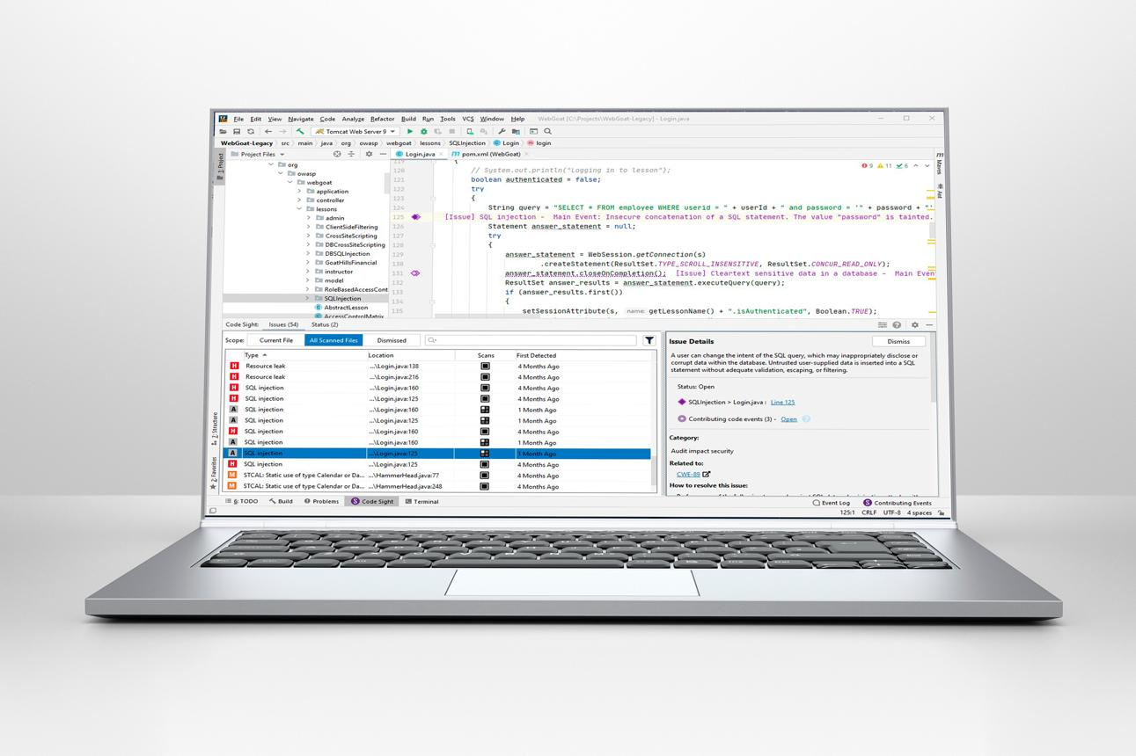
2. Static analysis
Tools analyse source code or other technical artefacts without running the program.
Example: A code-analysis tool flags an unused variable, a possible null-reference issue or a potential security weakness.
Static analysis vs review
Reviews | Static analysis
Usually involves people examining a work product | Usually uses automated tools
Can identify ambiguity and missing business rules | Can identify coding patterns and certain technical issues
Example: Requirement is unclear | Example: Code may dereference a null value
Depends on reviewer skills and preparation | Depends on tool rules, configuration and analysis capabilities
Both approaches can complement each other. Neither guarantees that all defects will be found.
3. Types of Testing Techniques
Testing techniques are methods used to design tests or examine software systematically. In this syllabus, distinguish static testing techniques from the broader family of test-design techniques.
A. Static testing techniques
- Informal review: Colleagues examine a document or code without a highly structured process.
- Walkthrough: The author guides participants through a work product to explain it and gather feedback.
- Technical review: Technically qualified reviewers examine a work product for correctness and suitability.
- Inspection: A formal, structured review that uses defined roles, preparation, documented findings and follow-up.
- Static analysis: A tool examines code or another artefact without executing the program.
B. Other common test-design techniques
These are broader testing techniques, not all forms of static testing.
Technique | Simple meaning | Example
Equivalence partitioning | Divide inputs into groups expected to behave similarly | Valid vs invalid transfer amounts
Boundary value analysis | Check values at and near limits | ₹49,999, ₹50,000 and ₹50,001
Decision table testing | Check combinations of conditions and their outcomes | Transfer allowed based on balance, account status and limit
State transition testing | Check how the system moves between states | Account changes from active to locked after specified failed logins
Statement coverage | Check which executable statements have been exercised | Execute statements in the transfer function
Branch coverage | Check decision outcomes in the code | Test both true and false branches of a condition
Important distinction: Equivalence partitioning and boundary value analysis are normally used to design test cases. Statement and branch coverage are commonly associated with white-box testing. They are not the same as reviews or static analysis.
4. Static Testing vs Dynamic Testing
This is one of the most important distinctions for an L1 assessment.

Static testing
Examines software work products without executing the software.
Example: Review a login requirement and identify that the lockout rule is missing.
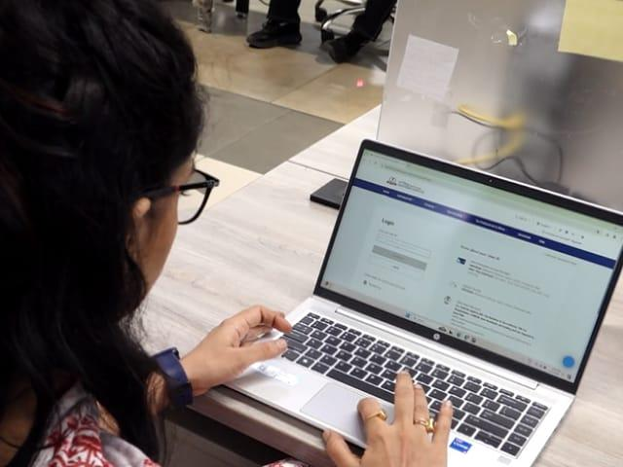
Dynamic testing
Executes the software with selected inputs and evaluates the observed behaviour.
Example: Enter incorrect passwords into the running banking application and verify the expected error message.
Comparison | Static testing | Dynamic testing
Software execution | Not required | Required
Main activities | Reviews and static analysis | Running tests and observing results
When it can start | Very early, even before code is executable | Once the relevant software or component can be executed
Typical findings | Ambiguous requirements, missing logic, coding-standard violations | Incorrect outputs, crashes, performance problems
Example | Review a transfer design | Execute a transfer test
Tools | Linters, static-analysis tools, review checklists | Playwright, test runners, performance-testing tools
Real business situation
Suppose a developer writes code for a bank's interest calculation.
- Static testing: Review the formula and identify that the annual interest rate has been applied incorrectly.
- Dynamic testing: Run the calculation with test inputs and compare the actual result with the expected result.
Both approaches can detect different kinds of problems. A strong testing process uses them together.
Remember: Static testing checks work products without executing the software. Dynamic testing checks behaviour by executing it.
5. Static Testing Basics and Work Products Examined
A work product is any output created during a software project's lifecycle.
Static testing can be applied to more than source code.
Work product | What can be checked? | Banking example
Business requirements | Completeness and clarity | Is the transfer limit clearly defined?
User stories | Business value and acceptance criteria | Is the expected behaviour for failed transfers specified?
Architecture documents | Design consistency and risks | Are account and payment services designed to communicate correctly?
Design diagrams | Missing steps and inconsistent flows | Does the transfer flow handle insufficient funds?
Source code | Coding standards and possible defects | Could a null account value cause an error?
Test plans | Scope, resources and coverage | Are security and transfer-limit risks included?
Test cases | Correctness and completeness | Are both valid and invalid transfers covered?
User documentation | Accuracy and clarity | Do the instructions explain transfer limits correctly?
Contracts or interface specifications | Consistency of agreed interfaces | Do the sender and receiver agree on API fields and formats?
Static testing of source code
A static-analysis tool may identify:
- Unused variables.
- Unreachable code.
- Possible null-reference errors.
- Certain security weaknesses.
- Violations of coding standards.
- Suspicious coding patterns.
However, a tool's warning needs interpretation. Some findings may be false positives, and the tool may miss defects outside its detection capabilities.
Static testing of requirements
Consider this requirement:
"The system must process transfers quickly."
A reviewer may ask:
- How quickly?
- Under what workload?
- What is the acceptable response time?
- Does the requirement apply to all transfers or only normal transfers?
The requirement is too vague to verify objectively. A more testable requirement would define a measurable response-time target and the conditions under which it must be met.
Business value: Clear requirements reduce misunderstandings, rework and disputes about whether a feature is complete.
6. Benefits of Static Testing
Static testing is valuable because it helps teams discover problems before those problems become expensive to fix.
Major benefits
- Early defect detection: Problems can be found before code is executed or a feature is completed.
- Lower rework costs: Correcting a requirement is often easier than changing implemented code and retesting multiple features.
- Better requirements: Reviews can reveal ambiguity, omissions and contradictions.
- Improved code quality: Static analysis can flag suspicious patterns and coding-standard violations.
- Improved security: Some tools and reviews can identify potential security weaknesses.
- Better test coverage: Reviewing test cases can reveal missing scenarios before execution.
- Knowledge sharing: Review participants learn about the product and each other's work.
- Reduced project risk: Early findings help teams make better development and release decisions.
Business example
A company is developing an online shopping website. During a requirements review, a tester notices that the discount rules do not specify whether two coupons can be combined.
If the ambiguity is found before development, the business team can clarify the rule. Otherwise, the developer might implement the wrong behaviour, and the team might need to redesign and retest checkout later.
Are there limitations?
Yes. Static testing cannot demonstrate every runtime behaviour. A code review may miss a performance issue that only occurs under heavy traffic, while a static-analysis tool may miss a defect that depends on complex runtime conditions.
Best approach: Combine static testing with appropriate dynamic testing.
7. Review Process
A review is a systematic examination of a work product to identify defects, improve quality and check whether it meets its objectives.
A review can be informal or highly formal, depending on the purpose, risk and project process.
Typical review process
1
Planning
Define the purpose, scope, participants and review approach.
2
Review initiation
Share the work product, required background and relevant checklists.
3
Individual preparation
Participants examine the work product and note potential defects.
4
Review meeting (when applicable)
Discuss findings, clarify issues and record defects.
5
Rework
The author corrects the identified issues.
6
Follow-up
Check that corrections are complete and decide whether further review is needed.
The precise steps vary by review type. For example, an informal review may not have a formal meeting, while an inspection normally follows a defined procedure.
Business example: Reviewing a payment feature
The team reviews the test cases for online payments.
- Planning: Decide which payment requirements need review.
- Preparation: Each reviewer checks the test cases independently.
- Review: Participants identify missing tests for payment timeouts and duplicate requests.
- Rework: The author updates the test cases.
- Follow-up: The review lead verifies that the agreed changes were made.
This prevents avoidable gaps from carrying into test execution.
8. Work Product Review Process
The work product review process focuses on examining a particular artefact, such as a requirement document, source-code module or test plan.
A useful review checklist might include:
- Is the information complete?
- Is it clear and unambiguous?
- Is it consistent with related documents?
- Does it satisfy the requirements?
- Are important scenarios missing?
- Can the work product be verified or tested?
- Does it follow the applicable standards?
- Are security, reliability and business risks considered where relevant?
Example: Reviewing a login requirement
Original requirement:
"The application should lock an account after repeated failed login attempts."
The reviewer asks:
- How many failed attempts are allowed?
- How long does the lockout last?
- What message is displayed?
- How is the user allowed to regain access?
- Does the rule apply to all supported login methods?
These questions help make the requirement complete and testable.
Important: A review finding is not necessarily a confirmed software defect. It can also be a question, ambiguity, inconsistency or improvement suggestion that needs investigation.
9. Roles and Responsibilities in a Formal Review
A formal review assigns specific responsibilities so that the review is organised, objective and effective.
Role | Responsibility | Business example
Manager | Decides on review policy, resources or participation where applicable | Ensures the team has time to review a critical payment design
Review leader / moderator | Organises and facilitates the review | Schedules the review and keeps discussion focused
Author | Creates the work product and corrects agreed defects | Updates the transfer test cases
Reviewer | Examines the work product and identifies findings | Finds that insufficient-balance scenarios are missing
Scribe / recorder | Records findings, decisions and actions | Documents the missing scenarios and assigns follow-up
Reviewers with specialist knowledge | Contribute relevant expertise | A security specialist checks access-control requirements
The exact role names and responsibilities may vary between organisations. In a formal inspection, these responsibilities are more explicitly defined.
How the roles work together
Suppose a team is reviewing a payment-system design.
- The review leader arranges the review.
- The author explains the design when needed.
- The reviewers identify potential problems.
- The scribe records the findings.
- The manager, when involved, provides resources or makes appropriate process decisions.
The purpose is to improve the work product, not to blame the author.
10. Review Types
Reviews vary in formality, purpose and the amount of structure they require.
1. Informal Review
Low formality
Colleagues examine a work product without a prescribed formal process.
Example: A tester asks a teammate to quickly check a new set of login test cases before execution.
Useful for: Quick feedback and early problem detection.
2. Walkthrough
Author-led
The author guides participants through the work product, explains decisions and collects feedback.
Example: A developer walks the team through the payment workflow and explains how timeout handling is intended to work.
Useful for: Knowledge sharing, learning, gathering feedback and identifying issues.
3. Technical Review
Technical focus
Technically qualified reviewers evaluate whether a work product is technically correct, suitable and consistent with requirements or standards.
Example: Engineers review whether a payment API design handles errors and data exchange correctly.
Useful for: Technical correctness and design decisions.
4. Inspection
High formality
A structured review with defined roles, preparation, documented findings, entry/exit criteria and follow-up.
Example: A critical financial calculation module undergoes a formal code inspection before release.
Useful for: High-risk work products and systematic defect detection.
Compare the review types
Feature | Informal review | Walkthrough | Technical review | Inspection
Formality | Low | Varies | Usually structured | High
Who typically leads? | Varies | Author | Moderator or technical lead | Trained moderator
Main emphasis | Quick feedback | Explanation and shared understanding | Technical quality | Systematic defect detection
Formal records | Not always | Depends on process | Usually appropriate records | Documented findings and follow-up
These descriptions reflect common testing terminology; individual companies may define their review procedures differently.
L1 memory tip: Inspection is generally the most formal of these review types.
11. Applying Review Techniques
The most suitable review technique depends on what needs to be checked, how critical the work product is and how much time is available.
Technique 1: Checklist-based review
Reviewers use a prepared list of questions to check important aspects of a work product.
Business example: A tester reviewing banking login test cases uses this checklist:
- Is valid login tested?
- Is invalid login tested?
- Are blank fields tested?
- Is account lockout covered?
- Are error messages checked?
- Are security requirements considered?
Benefit: Helps reviewers remember important checks and improves consistency.
Limitation: A checklist may miss new or unusual issues if reviewers rely on it without thinking critically.
Technique 2: Scenario-based review
Reviewers consider realistic business situations and verify that the work product addresses them.
Example: Review payment test cases against these situations:
- Customer has sufficient balance.
- Customer has insufficient balance.
- The payment service times out.
- The customer submits the same request twice.
- The recipient account is invalid.
Benefit: Connects technical artefacts to real user behaviour and business requirements.
Technique 3: Perspective-based review
Reviewers examine the work product from the viewpoint of a particular stakeholder or role.
Example: Reviewing an online checkout design
- Customer perspective: Is checkout easy to understand?
- Tester perspective: Are all important scenarios testable?
- Security perspective: Is sensitive payment information protected?
- Business perspective: Are pricing, tax and discount rules correct?
Benefit: Different viewpoints can reveal different classes of problems.
Technique 4: Ad hoc review
Reviewers examine a work product using their knowledge and experience without a prescribed checklist or structured technique.
Example: An experienced tester reads a requirement document and notices an unusual situation involving duplicate payments.
Benefit: Can reveal unexpected issues quickly.
Limitation: Coverage depends heavily on the reviewer's expertise and may be inconsistent.
Which technique should you choose?
Situation | Suitable technique
A repeatable set of important requirements must be checked | Checklist-based review
The team needs to assess realistic user journeys | Scenario-based review
The product needs evaluation from multiple stakeholder viewpoints | Perspective-based review
An experienced colleague is giving quick feedback | Ad hoc review
A formal review type and a review technique are different concepts. For example, an inspection is a review type, while checklist-based review is a technique that may be used during an inspection.
Capgemini L1 Assessment Notes: Test Techniques
This topic is important for your V&V Automation Testing (Playwright, JavaScript, and TypeScript) training. For L1, focus on understanding each technique, identifying which technique fits a scenario, and solving small numerical or logic-based questions.
1. Categories of test techniques
A test technique is a method used to design test cases and decide what to test.
There are three main categories:
1. Black-box testing
Tests the software's behavior without looking at its internal code.
Example: Enter different passwords into a login page and check the results.
2. White-box testing
Tests internal code logic, statements, branches, and execution paths.
Example: Check whether both the true and false branches of a password-validation condition execute.
3. Experience-based testing
Uses a tester's experience, intuition, previous defects, and checklists to identify possible problems.
Example: A tester tries submitting a form twice because duplicate submissions are a common problem.
Characteristics at a glance
Category | Main basis | Knowledge needed
Black-box | Requirements and expected behavior | What the system should do
White-box | Code and internal logic | How the system works internally
Experience-based | Tester knowledge and experience | Common mistakes and likely risks
2. Choosing test techniques
The best technique depends on:
- Requirements: What must the application do?
- Risk: Which failures would cause the most damage?
- Time and budget: How much testing time is available?
- Application complexity: How many conditions and states exist?
- Tester skills: What tools and technical knowledge are available?
- Test objectives: Are you checking functionality, code coverage, or common errors?
Real-life example: For an online banking application, use boundary testing for transfer limits, decision tables for transaction rules, state transition testing for transaction statuses, and white-box testing for internal validation logic.
You can combine multiple techniques for better coverage.
3. Black-box test techniques
A. Equivalence Partitioning (EP)
Meaning: Divide input data into groups, or partitions, where the application is expected to behave similarly. Test one representative value from each group.
Example: A registration form accepts ages from 18 to 60 inclusive.
Partition | Input range | Example test
Invalid: too young | Below 18 | 17
Valid | 18–60 | 35
Invalid: too old | Above 60 | 61
Instead of testing every possible age, select representative values from each partition.
Memory trick: One representative value per group.
Likely L1 question: If a field accepts values from 1 to 100, which technique divides inputs into valid and invalid groups? Answer: Equivalence Partitioning.
B. Boundary Value Analysis (BVA)
Meaning: Test values at the edges of an allowed range because errors often occur at boundaries.
Using the same age rule of 18–60 inclusive, the key boundary values are:
Test | Input | Expected result
Just below minimum | 17 | Reject
Minimum | 18 | Accept
Just above minimum | 19 | Accept
Just below maximum | 59 | Accept
Maximum | 60 | Accept
Just above maximum | 61 | Reject
For this example, the six values are 17, 18, 19, 59, 60, and 61.
Memory trick: Test just below, at, and just above a boundary.
Difference between EP and BVA
- EP tests representative values from different groups.
- BVA focuses on the edges of valid and invalid ranges.
Quick example
A website accepts a transfer amount from ₹100 to ₹50,000 inclusive.
- EP: Test ₹50, ₹1,000, and ₹60,000.
- BVA: Test ₹99, ₹100, ₹101, ₹49,999, ₹50,000, and ₹50,001.
C. Decision Table Testing
Meaning: Use a table to test combinations of conditions and their corresponding actions.
It is useful when the application's output depends on multiple rules.
Business example: Online banking transaction
Suppose a transfer is approved only when:
- The account is active.
- The available balance is sufficient.
Condition/action | Rule 1 | Rule 2 | Rule 3 | Rule 4
Account active? | Yes | Yes | No | No
Sufficient balance? | Yes | No | Yes | No
Approve transfer? | Yes | No | No | No
Each column represents a combination of conditions. Test each relevant rule to verify the correct result.
Memory trick: Multiple conditions + combinations of rules = Decision Table.
Likely question: Which technique is best when the output depends on combinations of conditions? Answer: Decision Table Testing.
D. State Transition Testing
Meaning: Test how a system changes from one state to another when an event occurs.
It is useful for workflows, login attempts, order statuses, and payment processing.
Active account
Too many failed login attempts
Temporarily locked
Unlock condition is satisfied
Active account again
Tests should verify that valid transitions occur and invalid transitions are rejected.
Memory trick: State + event = possible state change.
Likely question: Which technique is suitable for testing an order moving from Placed → Shipped → Delivered? Answer: State Transition Testing.
E. Use Case Testing
Meaning: Design tests based on how a user interacts with the system to achieve a goal. A use case often contains a main flow and alternative or exception flows.
Example: Purchasing a product online
- Main flow: Log in → select product → add to cart → pay → receive confirmation.
- Alternative flow: Apply a valid discount coupon.
- Exception flow: Payment fails or the product becomes unavailable.
The tester checks whether the complete user journey behaves correctly.
Memory trick: User goal + end-to-end journey = Use Case Testing.
Likely question: Which technique is best for testing a complete customer journey from login to checkout? Answer: Use Case Testing.
Black-box techniques: quick comparison
Technique | Best suited for
Equivalence Partitioning | Grouping similar inputs
Boundary Value Analysis | Testing range edges
Decision Table Testing | Combinations of conditions
State Transition Testing | Changes between states
Use Case Testing | Complete user workflows
4. White-box test techniques
White-box testing examines the internal program logic. Two important techniques are statement testing and decision testing.
A. Statement Testing and Statement Coverage
Meaning: Design tests to execute the program's executable statements.
Statement coverage tells us what percentage of executable statements ran during testing.
\[ \text{Statement Coverage} = \frac{\text{Statements executed}}{\text{Total executable statements}} \times 100 \]
Consider this JavaScript code:
function checkAge(age) {
if (age >= 18) {
console.log("Eligible");
}
console.log("Check complete");
}
Suppose we test only age = 20.
- console.log("Eligible") executes.
- console.log("Check complete") executes.
- Both executable statements run.
Statement coverage = \(2/2 \times 100 = 100\%\).
However, the age >= 18 condition has only been tested as true. We have not checked what happens for an age below 18.
Important: 100% statement coverage does not guarantee that every decision outcome has been tested.
B. Decision Testing and Decision Coverage
Meaning: Design tests to make each decision produce every possible outcome, usually True and False.
Decision coverage tells us what percentage of decision outcomes have been exercised.
\[ \text{Decision Coverage} = \frac{\text{Decision outcomes exercised}}{\text{Total decision outcomes}} \times 100 \]
Using the previous example:
Test input | Condition age >= 18 | Result
age = 20 | True | Eligible
age = 16 | False | No eligibility message
The condition has two possible outcomes: True and False. Testing both gives 100% decision coverage for this decision.
Important: For a simple if statement, test both the true and false outcomes. For more complex code, there may be multiple decisions and outcomes.
C. Statement Coverage vs Decision Coverage
Statement testing | Decision testing
Focuses on executable statements | Focuses on decision outcomes
Checks whether statements ran | Checks whether outcomes were exercised
Can miss an untested branch | Requires each decision outcome
100% statement coverage may be achieved without 100% decision coverage | 100% decision coverage normally exercises all reachable outcomes of the decisions being measured
Exam tip: Decision coverage is generally stronger than statement coverage for simple branching code, but neither guarantees that all possible paths or combinations have been tested.
D. Value of statement and decision testing
These techniques help testers:
- Identify code that has not been executed.
- Find missing or incorrectly implemented branches.
- Measure test coverage objectively.
- Improve the quality of unit tests.
- Find logic errors before the software reaches production.
But coverage is not the same as quality. Tests must also check whether the actual results are correct.
5. Experience-based test techniques
These techniques use a tester's experience and knowledge to find defects that structured test cases might miss.
A. Error Guessing
Meaning: Predict likely errors based on experience, common mistakes, and previously discovered defects.
Examples:
- Submitting a form with empty fields.
- Entering spaces instead of a username.
- Clicking the Pay button twice.
- Entering special characters in a search box.
- Refreshing a page during a transaction.
Memory trick: Predict the mistakes that might happen.
Likely question: A tester tries duplicate payment submissions because similar defects occurred before. Which technique is this? Answer: Error Guessing.
B. Exploratory Testing
Meaning: The tester learns about the application, designs tests, and executes them while exploring the system.
Unlike strictly scripted testing, exploratory testing allows the tester to adapt based on what they discover.
Example: While exploring an e-commerce checkout, a tester changes the delivery address, applies a coupon, removes a product, and checks whether the total is recalculated correctly.
Typical activities include:
- Understand the feature and define a testing goal.
- Explore the application.
- Design and execute tests as you learn.
- Record findings and defects.
- Investigate suspicious behavior further.
Memory trick: Learn, explore, test, and adapt.
C. Checklist-based Testing
Meaning: Use a predefined list of checks to make sure important areas are not forgotten.
Example: Login-page checklist
- Valid username and password work.
- Invalid password is rejected.
- Empty fields are handled correctly.
- Password is masked.
- Error messages are understandable.
- Login works on supported browsers.
- Repeated failed attempts are handled correctly.
Memory trick: A prepared list of checks = Checklist-based Testing.
Compare the experience-based techniques
Technique | Main idea
Error Guessing | Predict likely defects
Exploratory Testing | Explore and test as you learn
Checklist-based Testing | Follow a prepared list of checks
6. How these techniques relate to Playwright automation
Since your training involves Playwright, JavaScript, and TypeScript, here is how you can apply the techniques in practical automation.
Technique | Example automation test
EP | Test one valid age and representative invalid ages
BVA | Test ages 17, 18, 19, 59, 60, 61
Decision Table | Test all relevant combinations of account status and balance
State Transition | Verify an order moves from Placed to Shipped
Use Case | Automate login → add to cart → checkout
Statement/Decision Coverage | Inspect code coverage and test both branches of validation logic
Error Guessing | Try double-clicking Pay or submitting an empty form
Exploratory | Investigate unexpected behavior while interacting with the application
Checklist-based | Automate or manually verify each item on a login checklist
Remember: Playwright is an automation tool, not a test design technique. You can use Playwright to automate test cases designed using these techniques, where appropriate.
7. Predicted L1 practice questions
These are practice questions based on the syllabus, not verified questions from Capgemini's actual assessment.
Capgemini L1 Assessment Notes: Test Management & Test Metrics
This topic focuses on how testing is planned, organized, estimated, monitored, and reported in a software project.
For your V&V Automation Testing training, imagine Capgemini is testing an online banking application. The team must decide what to test, who will test it, how much time is needed, which risks matter most, how defects are tracked, and when testing can be completed.
1. Test Organization and Independent Testing
What is test organization?
Test organization defines who performs testing, what their responsibilities are, and how the testing team works with developers and project managers.
Common roles include:
- Test Manager: Manages the overall testing process.
- Tester: Designs, executes, and evaluates tests.
- Developer: Builds the application and fixes defects.
- Business Analyst/Product Owner: Clarifies requirements and business expectations.
- Project Manager: Coordinates project scope, schedule, resources, and delivery.
What is independent testing?
Independent testing means testing is performed by someone other than the person who developed the item being tested.
For example, a developer builds a bank transfer feature, while a separate tester checks whether the transfer works correctly.
Different levels of independence can exist:
- The developer tests their own code.
- Another developer or teammate tests it.
- A separate testing team tests it.
- An independent organization tests it.
Benefits: Different perspectives, less developer bias, and a greater chance of finding overlooked defects.
Important: Independence does not guarantee quality. Developers' tests are still valuable, especially for unit testing, and collaboration between developers and testers is essential.
2. Tasks of a Test Manager and a Tester
Test Manager | Tester
Develops the test plan and testing approach | Reviews requirements
Estimates time, effort, and resources | Designs and prepares test cases
Assigns tasks and coordinates the team | Prepares test data
Monitors progress and testing metrics | Executes manual or automated tests
Manages testing risks and escalations | Compares actual and expected results
Reports status to stakeholders | Logs defects and retests fixes
Ensures testing objectives are addressed | Performs regression testing and reports results
Example: For a banking application, the test manager schedules payment testing and assigns responsibilities. The tester checks successful transfers, insufficient balance, and invalid account details.
Memory tip: Manager = plan, organize, monitor. Tester = design, execute, report.
3. Test Planning, Estimation, Strategy, and Approach
These terms are related, but they do not mean the same thing.
Term | Meaning | Example
Test planning | Deciding what will be tested, by whom, when, and with what resources | Create a schedule for payment testing
Test estimation | Predicting the effort, time, and cost required | Estimate 5 tester-days for checkout testing
Test strategy | The high-level principles and direction for testing | Prioritize high-risk banking transactions
Test approach | How testing will be performed for a particular project or test level | Use Playwright for browser automation and manual testing for exploratory checks
Example: E-commerce checkout
- Planning: Test checkout before release.
- Estimation: Estimate three days for preparation and execution.
- Strategy: Prioritize payment failures and incorrect order totals.
- Approach: Automate successful checkout and common validation scenarios using Playwright.
A test strategy is generally broader than a project-specific test approach. The exact terminology can vary between organizations.
4. Purpose and Contents of a Test Plan
A test plan is a document describing the objectives, scope, resources, schedule, and activities of testing.
Why is a test plan needed?
- Gives the team a clear direction.
- Defines responsibilities.
- Helps manage time and resources.
- Identifies risks and dependencies.
- Provides a basis for monitoring progress.
Common contents of a test plan
Item | What it describes
Test objectives | What testing should achieve
Scope | What is included and excluded
Test approach | Techniques, test levels, and automation
Resources and roles | Who will do the work
Schedule | When activities occur
Test environment | Browsers, servers, devices, and tools
Test data | Data required for execution
Risks and mitigations | Potential problems and responses
Entry and exit criteria | Conditions for starting and completing testing
Deliverables | Test cases, scripts, reports, defect records
L1 tip: If a question asks which document defines the scope, schedule, resources, and approach of testing, the answer is usually the test plan.
5. Entry Criteria, Exit Criteria, Definition of Ready, and Definition of Done
Entry criteria
Conditions that must be satisfied before a testing activity can begin.
Example:
- Requirements are available.
- A test environment is ready.
- Required test data is prepared.
- The build has passed basic smoke tests, if required by the plan.
Exit criteria
Conditions that must be satisfied before a testing activity can be considered complete.
Example:
- All planned high-priority tests have been executed.
- No unacceptable critical defects remain open.
- Required coverage targets have been met.
- Test results have been documented.
Exit criteria do not necessarily mean that every test must pass. Unresolved defects may be accepted through an authorized risk decision.
Definition of Ready (DoR) vs Definition of Done (DoD)
Definition of Ready | Definition of Done
Conditions needed before work starts | Conditions needed before work is considered complete
Focuses on readiness | Focuses on completion and quality
Example: A user story has clear acceptance criteria | Example: Code, tests, review, and agreed acceptance checks are complete
Remember: Entry = ready to begin testing. Exit = ready to finish testing. DoR and DoD are broader team agreements often used in Agile development.
6. Test Execution Schedule and Factors Influencing Test Effort
What is a test execution schedule?
It shows which testing activities will happen, when they will happen, and in what order.
Example:
Day | Activity
Day 1 | Review requirements and prepare test data
Day 2 | Execute functional tests
Day 3 | Automate important regression tests
Day 4 | Retest fixes and perform regression testing
Day 5 | Analyze results and prepare the test report
This is only an illustrative schedule; actual dates depend on project needs.
Factors influencing test effort
- Application size and complexity.
- Number and clarity of requirements.
- Tester experience and team size.
- Test coverage and quality targets.
- Automation framework readiness.
- Test environment stability.
- Availability of test data.
- Number and severity of defects.
- Regulatory or security requirements.
- Dependencies on other teams or systems.
Important distinction:
- Effort is the amount of work, often measured in person-hours or person-days.
- Duration is the elapsed calendar time needed.
For example, 10 person-days of work might take two days with five people if the work can be divided effectively. Dependencies and coordination can prevent a perfect one-to-one relationship.
7. Test Estimation Techniques
Test estimation predicts how much effort, time, and resources testing will require.
A. Estimation based on metrics
Use historical information from similar projects.
Example: A previous application needed 20 hours to test 40 similar test cases. A new project has 60 similar test cases.
Estimated effort:
\[ 20 \times \frac{60}{40}=30\text{ hours} \]
This assumes the test cases have roughly similar complexity.
B. Expert-based estimation
Experienced team members estimate the work using their knowledge.
Example: An experienced tester estimates that automating a login flow will take four hours based on similar work.
C. Three-point estimation
Estimate three possible effort values:
- Optimistic (O): Best reasonable case.
- Most likely (M): Expected case.
- Pessimistic (P): Worst reasonable case.
A common PERT formula is:
\[ E=\frac{O+4M+P}{6} \]
Example: O = 2 days, M = 4 days, P = 8 days.
\[ E=\frac{2+4(4)+8}{6}=4.33\text{ days} \]
D. Work breakdown-based estimation
Break the work into smaller activities and estimate each one.
Example:
Activity | Estimated effort
Requirement review | 3 hours
Test case preparation | 5 hours
Test execution | 8 hours
Defect retesting | 2 hours
Reporting | 2 hours
Total | 20 hours
This method helps identify where the effort will be spent.
L1 memory tip: Historical metrics, expert judgment, three-point estimation, and work breakdown are useful estimation approaches.
8. Test Monitoring and Test Control
Test monitoring
Monitoring means collecting and reviewing information about testing progress.
Questions answered:
- How many test cases have been executed?
- How many have passed or failed?
- How many defects remain open?
- Are we on schedule?
- Are important risks being addressed?
Test control
Control means taking action when monitoring identifies a problem.
Examples:
- Assign more testers to a delayed activity.
- Prioritize critical business functions.
- Update the schedule.
- Fix a blocked test environment.
- Add tests when a new risk is identified.
Easy difference: Monitoring tells you what is happening; control decides what to do about it.
Example
The team planned to execute 100 test cases by Wednesday but completed only 50.
- Monitoring: Reports that execution is behind schedule.
- Control: Investigates the cause and reallocates resources or adjusts priorities.
9. Testing Metrics and Test Reports
A test metric is a measurable value used to understand testing progress, quality, coverage, or efficiency.
Common testing metrics
Metric | What it measures
Test execution progress | Tests executed compared with planned tests
Pass rate | Percentage of executed tests that passed
Fail rate | Percentage of executed tests that failed
Requirements coverage | Percentage of requirements covered by tests
Defect density | Number of defects relative to a defined size measure
Defect leakage | Defects found after release that escaped earlier testing
Defect rejection rate | Percentage of reported defects rejected as invalid, duplicate, or not a defect, according to the team's classification
Automation coverage | Proportion of selected tests automated, using a clearly defined denominator
Test effort variance | Difference between actual and estimated effort
Useful formulas
Test execution progress
\[ \frac{\text{Tests executed}}{\text{Tests planned}}\times100 \]
Pass rate
\[ \frac{\text{Tests passed}}{\text{Tests executed}}\times100 \]
Fail rate
\[ \frac{\text{Tests failed}}{\text{Tests executed}}\times100 \]
Suppose 80 tests have been executed out of 100 planned, with 68 passing and 12 failing.
- Execution progress = \(80/100 \times 100 = 80\%\)
- Pass rate = \(68/80 \times 100 = 85\%\)
- Fail rate = \(12/80 \times 100 = 15\%\)
Note that the pass rate is calculated using executed tests, not all planned tests.
What is a test report?
A test report communicates testing progress, results, quality concerns, and recommendations to relevant stakeholders.
Common contents:
- Summary of testing performed.
- Scope and test environment.
- Planned vs completed activities.
- Pass/fail/blocked test counts.
- Defects and their severity.
- Coverage and risk status.
- Deviations from the plan.
- Outstanding issues and limitations.
- Recommendation or release-readiness assessment.
Audiences for test reports
Audience | What they need
Test manager | Progress, defects, resources, and schedule
Project manager | Delivery risks, milestones, and impact
Developers | Reproducible defects and technical details
Business stakeholders | Business impact and remaining risks
Senior management | High-level status and release recommendation
A detailed report is useful for the testing team, while an executive summary is usually more appropriate for senior management.
10. Configuration Management
Configuration management ensures that the correct versions of software, test scripts, requirements, test data, and environments are identified and controlled.
Why is it important?
Imagine a tester executes a test against an older application build and reports a defect that has already been fixed in the latest build. The team may waste time investigating a problem that no longer exists.
Configuration management helps avoid this confusion.
It commonly involves:
- Version control: Tracking changes to code and test scripts.
- Version identification: Knowing exactly which build was tested.
- Change control: Reviewing and approving changes.
- Configuration status tracking: Recording versions and change status.
- Baseline management: Maintaining an agreed reference version.
Practical Playwright example
A team stores automation scripts in Git. When a test fails, the team checks:
- Which code version was tested?
- Which version of the test script ran?
- Which browser and environment were used?
- Did the application change recently?
This helps reproduce failures accurately.
L1 question: Which practice ensures the correct versions of software and test artifacts are used? Answer: Configuration Management.
11. Risks and Testing
A risk is a possible future event or condition that could have a negative impact.
In testing, risk assessment helps the team decide where to focus limited time and resources.
Two major categories are product risk and project risk.
A. Product risks
Product risks relate to the quality or behavior of the software itself.
Examples:
- Incorrect bank balance calculation.
- Duplicate payments.
- Security vulnerabilities.
- Slow checkout during peak traffic.
- Lost customer information.
These risks can affect users, business operations, or the organization.
B. Project risks
Project risks relate to the delivery and execution of the project.
Examples:
- Insufficient testing time.
- Key testers leaving the team.
- Unavailable test environments.
- Delayed requirements.
- Automation tools not being ready.
These risks can affect cost, schedule, resources, and project delivery.
Product risk vs project risk
Product risk | Project risk
Affects the quality of the product | Affects the project or its delivery
Example: Incorrect transaction amount | Example: Testing starts late
Managed by testing and development activities, among others | Managed through planning, resourcing, coordination, and mitigation
12. Risk-Based Testing
Risk-based testing prioritizes testing based on the likelihood of failure and the impact if failure occurs.
A simple risk score is:
\[ \text{Risk Score}=\text{Likelihood}\times\text{Impact} \]
For example, if likelihood and impact are each scored from 1 to 5:
Feature | Likelihood | Impact | Risk score
Bank transfer | 4 | 5 | 20
Login page | 3 | 5 | 15
Profile theme setting | 2 | 1 | 2
In this illustrative example, bank transfers receive the highest testing priority.
Risk-based testing helps teams:
- Test high-risk features more thoroughly.
- Allocate limited time effectively.
- Decide which tests should run first.
- Identify areas that may need extra regression testing.
- Make informed decisions about remaining risks.
Important: A low-risk feature should not automatically be ignored. The level of testing should be appropriate to the risk and the agreed quality objectives.
13. Defect Management and Defect Metrics
A defect is a flaw in a work product that may cause the software to behave incorrectly or fail to meet a requirement.
Typical defect management workflow
Defect identified
Defect logged
Defect triaged and assigned
Developer fixes defect
Tester retests the fix
Fix verified and defect closed
If the defect still exists after retesting, it may be reopened. If the fix causes problems elsewhere, regression testing may be required.
Common defect statuses
- New/Open: Reported and awaiting action.
- Assigned: Given to a responsible person.
- In Progress: Being investigated or fixed.
- Fixed/Resolved: A proposed fix is available.
- Retest: Tester checks the fix.
- Closed: Fix verified and defect accepted as resolved.
- Reopened: The defect persists or returns.
- Rejected/Invalid: Determined not to be a valid defect under the team's process.
- Deferred: Fix postponed by an authorized decision.
Status names and workflow vary between organizations.
Severity vs priority
Severity | Priority
How serious the defect's impact is | How urgently it should be fixed
Usually based on technical or business impact | Based on urgency and business needs
Example: A payment calculation gives the wrong total | Example: A minor visual issue on a page used in a major demonstration must be fixed urgently
A critical defect often has high priority, but severity and priority are not the same.
Important defect metrics
Metric | Meaning
Defect count | Number of reported defects
Defect density | Defects per defined size unit, such as a module or thousand lines of code
Defect leakage | Defects discovered after release that were not found before release
Defect rejection rate | Proportion of reported defects rejected as invalid or otherwise not accepted
Defect reopening rate | Proportion of closed defects that are reopened
Defect resolution time | Time taken to resolve a defect
Open defect count | Number of defects still unresolved
Defect distribution by severity | How defects are divided among severity levels
Exam trap: A high number of defects does not always mean testing is poor. It may mean the team is testing thoroughly or that the product has significant quality issues. Metrics must be interpreted in context.
Capgemini L1 Assessment Notes — Requirements Engineering, Use Case Testing & Software Versioning
These topics are about understanding what the customer needs, how to document requirements, how to test user workflows, and how software versions are managed.
For your V&V Automation Testing training, connect each concept to practical applications such as banking, e-commerce, and Playwright-based browser testing.
Part 1: Requirements Engineering
1. What is Requirements Engineering?
Requirements Engineering (RE) is the process of identifying, analyzing, documenting, validating, and managing what a software system must do.
Example: A bank wants to build an online banking application.
Its requirements may include:
- Customers must be able to log in.
- Customers must be able to transfer money.
- The system must protect customer information.
- A transfer should display its final status.
Requirements Engineering ensures that the development and testing teams understand what needs to be built.
Typical requirements engineering activities
1
Elicitation
Gather requirements from stakeholders
2
Analysis
Check feasibility, conflicts, and clarity
3
Specification
Document requirements clearly
4
Validation
Confirm requirements meet stakeholder needs
5
Management
Track changes throughout the project
2. Evolution of Requirements
Requirements often change as a project progresses.
For example, an online shopping website initially supports cash on delivery. Later, customers request UPI payments, and the business adds that feature.
Requirements evolve because of:
- Customer feedback.
- Changes in business goals.
- New laws or regulations.
- Technology changes.
- Competition and market needs.
- Problems discovered during development or testing.
Key point: Requirements should be managed throughout the software lifecycle, not just collected at the beginning.
3. Requirements Gathering Challenges
Gathering requirements means understanding what stakeholders actually need.
Common challenges include:
Challenge | Example
Ambiguous requirements | “The page should load quickly.”
Conflicting requirements | One stakeholder wants strict security; another wants fewer login steps
Missing requirements | The team forgets the password-reset feature
Changing requirements | UPI payments are added after development begins
Communication gaps | The customer says “account,” but the team misunderstands which account type
Unrealistic expectations | The customer wants a complex application delivered immediately
Unavailable stakeholders | The team cannot get answers to important questions
Good practice: Ask questions, clarify terms, document acceptance criteria, and confirm the requirements with stakeholders.
4. Characteristics of Good and Bad Requirements
A good requirement should be:
- Clear: Easy to understand.
- Complete: Includes the necessary information.
- Consistent: Does not conflict with other requirements.
- Testable: Can be verified objectively.
- Feasible: Can reasonably be implemented.
- Traceable: Can be linked to its source and related tests.
- Unambiguous: Has only one reasonable interpretation.
- Prioritized: Its importance is understood.
Example
Bad requirement:
The application should be fast and user-friendly.
Why is it bad? “Fast” and “user-friendly” are subjective and difficult to measure.
Improved requirement:
Under the agreed test conditions, the product search page shall display results within two seconds for at least 95% of requests.
Now the team has a measurable condition to verify.
Impact of bad requirements
Bad requirements can cause:
- Incorrect features.
- More defects and rework.
- Increased development costs.
- Delays in delivery.
- Disagreements between customers and developers.
- Difficulty designing effective test cases.
L1 memory tip: A requirement that cannot be understood clearly or tested objectively is likely to create problems later.
5. Functional vs Non-Functional Requirements — FURPS+
Functional requirements
Describe what the system must do.
Examples:
- A customer can log in using valid credentials.
- A user can transfer money.
- The application sends an order confirmation.
- A user can reset a password.
Non-functional requirements
Describe how well the system should operate or the constraints under which it operates.
Examples:
- Search results should appear within two seconds under specified conditions.
- The system must protect sensitive customer data.
- The application must support specified browsers.
- The service must meet an agreed availability target.
FURPS+
FURPS+ is a way to classify different quality requirements and constraints.
Letter | Category | Example
F | Functionality | Login, payments, search
U | Usability | Easy navigation and clear error messages
R | Reliability | System operates consistently without unexpected failures
P | Performance | Response time and throughput
S | Supportability | Ease of maintenance, testing, and support
+ | Additional constraints | Security, design, implementation, interface, and physical constraints
The exact grouping of additional requirements can vary by reference, but the central idea is that FURPS+ covers more than features alone.
Quick distinction: “The user can reset a password” is functional. “The reset page responds within two seconds” is a performance requirement.
6. Stable vs Volatile Requirements
Stable requirements
Requirements that are expected to remain relatively unchanged over time.
Example: A banking system must maintain transaction records.
Volatile requirements
Requirements likely to change because of business, legal, market, or user needs.
Example: A shopping application changes its discount rules for a seasonal sale.
Stable | Volatile
Changes infrequently | May change frequently
Often tied to core business needs | Often tied to changing conditions
Example: Maintain customer account records | Example: Update promotional rules
These categories are relative: a stable requirement can still change.
7. Baselining Requirements
A requirements baseline is an agreed and controlled version of requirements used as a reference for development and testing.
Example:
The bank approves version 1.0 of its requirements. After that, adding a new payment method normally requires a formal change request and impact analysis.
Why baseline requirements?
- Gives everyone a common reference.
- Helps track changes.
- Prevents unauthorized changes.
- Supports planning and testing.
- Makes it easier to understand why scope or estimates changed.
Important: A baseline does not mean requirements can never change. Changes are managed through an agreed process.
8. Requirements Traceability Matrix (RTM)
An RTM connects requirements to test cases and, where applicable, defects and test results.
Its main purpose is to ensure that requirements are covered by testing and that changes can be assessed.
Example RTM
Requirement ID | Requirement | Test case ID | Status
REQ-01 | User can log in | TC-01, TC-02 | Passed
REQ-02 | User can reset password | TC-03 | Passed
REQ-03 | Transfer requires sufficient balance | TC-04, TC-05 | One failed
REQ-04 | Transaction confirmation is displayed | TC-06 | Not run
This makes it easier to identify missing test coverage and failed tests.
Types of traceability
- Forward traceability: Requirement → test cases or implementation.
- Backward (reverse) traceability: Test cases or implementation → original requirement.
- Bidirectional traceability: Traceability in both directions.
Why is this useful?
- Confirms every requirement has appropriate tests.
- Helps identify requirements without test coverage.
- Helps identify tests that do not map to an approved requirement.
- Supports impact analysis when requirements change.
- Helps track test completion.
Maintaining an RTM
Whenever requirements or tests change:
- Update the requirement record and version.
- Identify the affected test cases.
- Add or revise tests if necessary.
- Record relevant defect links and test status.
- Review coverage and confirm the RTM remains accurate.
For example, if a new rule limits daily transfers, update the requirement, add boundary and negative test cases, and link them to the new requirement.
L1 memory tip: RTM = Requirement Traceability Matrix. It connects requirements to tests and helps measure coverage.
9. Requirements Change Management
A requirements change is a proposed modification, addition, or removal of an existing requirement.
A typical change management process is:
1. Submit change request
Describe the proposed change and reason.
2. Analyze impact
Check cost, schedule, design, risks, and existing tests.
3. Review and approve/reject
Authorized stakeholders make the decision.
4. Update requirements and baseline
Record the approved change and version.
5. Update implementation and tests
Revise the RTM and affected test cases.
6. Verify the change
Test the feature and perform regression testing.
Example
A banking customer requests an increase in the daily transfer limit.
Before implementing the change, the team checks:
- Security and fraud risks.
- Business approval.
- Existing transfer validation.
- Related requirements and test cases.
- Whether the schedule and estimates must change.
After approval, the team updates the requirements, implementation, RTM, and tests.
10. Requirement Creep (Scope Creep)
Requirement creep happens when extra requirements keep getting added without adequate control of the agreed scope, schedule, resources, or budget.
Example:
A team agrees to build a login page. Later, someone asks for social login, biometric login, extra reports, and a dashboard without changing the deadline.
Possible consequences:
- Missed deadlines.
- Increased cost.
- Incomplete testing.
- Lower product quality.
- Team overload.
How to prevent it
- Define and baseline the scope.
- Use a formal change request process.
- Perform impact analysis.
- Obtain approval before implementation.
- Update estimates, schedules, and tests.
Exam distinction: A controlled, approved change is normal requirements management. Uncontrolled additions to scope lead to requirement or scope creep.
Part 2: Use Case Testing
11. What is Use Case Testing?
Use Case Testing designs tests around how a user interacts with a system to achieve a specific goal.
It is useful for testing complete workflows rather than only individual fields or functions.
Example: An online shopping user wants to purchase a product.
- Log in.
- Search for a product.
- Add it to the cart.
- Enter delivery details.
- Pay.
- Receive an order confirmation.
The tester verifies that the complete journey works and that the system handles alternative outcomes correctly.
12. Use Case Modeling and Its Advantages
Use case modeling describes how external users or systems interact with an application to achieve goals.
It commonly uses:
- Actors: People or external systems interacting with the application.
- Use cases: Goals or services the system provides.
- Relationships: Connections between actors and use cases.
- System boundary: What is inside and outside the system being modeled.
Example: In an online banking system, the customer is an actor, and “Transfer Money” is a use case.
Advantages:
- Clarifies system functionality.
- Helps identify user goals.
- Supports requirements discussions.
- Helps testers derive test scenarios.
- Makes alternative and failure paths easier to identify.
- Supports end-to-end testing.
13. Actors, Goals, Requirements, and Scenarios
Term | Meaning | Banking example
Actor | Person or external system interacting with the application | Customer
Goal | What the actor wants to achieve | Transfer money
Requirement | What the system must do | Validate balance before transfer
Scenario | A specific sequence of interactions and outcomes | Successful transfer with sufficient funds
An actor is not always a person. An external payment gateway or another system can also be an actor.
Use case example: Transfer Money
Use case: Transfer Money
Primary actor: Bank customer
Preconditions
- Customer is authenticated.
- Source account is active.
Main success scenario
- Customer enters recipient details.
- Customer enters the amount.
- System validates the details and available balance.
- Customer confirms the transfer.
- System processes the transaction.
- System displays the transaction reference and status.
Alternative path
- If the customer enters an amount above the allowed limit, the system displays a validation message.
Exception path
- If the payment service is unavailable, the system communicates the failure or pending status appropriately and avoids an incorrect duplicate transfer.
Postcondition
- The transaction has a consistent, recorded status, and the account balances reflect the actual transaction outcome.
Notice that the use case describes behavior from the user's perspective. The test cases then verify each path.
14. Naming Conventions for Use Cases and Test Cases
Good names make requirements and tests easier to understand and maintain.
Use case naming
Use a clear verb + object format.
Good examples:
- Transfer Money
- Reset Password
- Place Order
- Cancel Booking
- Generate Report
Avoid vague names such as:
- Banking
- Login Page
- Order System
Test case naming
Use a consistent ID and a description of the behavior being tested.
Test case ID | Test case name
TC-LOGIN-01 | Login with valid credentials
TC-LOGIN-02 | Reject login with an invalid password
TC-TRANSFER-01 | Transfer with sufficient balance
TC-TRANSFER-02 | Reject transfer exceeding the daily limit
Good test case names should be clear, specific, and easy to trace to the related requirement.
15. Main Flow, Alternative Paths, Exceptions, and Errors
A use case can have multiple paths.
Path | Meaning | Example
Main success flow | Normal sequence when everything works | Customer logs in and transfers money successfully
Alternative flow | A different valid way to continue or complete the goal | Customer selects a saved recipient instead of entering new details
Exception flow | An exceptional condition interrupts normal processing | Payment service becomes unavailable
Error scenario | An invalid action or failure must be handled correctly | Customer enters an invalid account number
Terminology may differ slightly between use case templates. The key is to identify the condition and expected system response.
L1 question: A customer enters an incorrect OTP. Which path should be tested? Answer: An alternative or exception/error path, depending on the use case's defined structure.
16. Preconditions and Postconditions
Preconditions
Conditions that must be true before a use case begins.
Examples:
- The customer is logged in.
- The account is active.
- Required information is available.
Postconditions
Conditions that should be true after the use case completes.
Examples:
- The order has been recorded.
- A transaction has an accurate final status.
- A password has been updated successfully.
Preconditions | Postconditions
Before execution | After execution
Establish the starting state | Define the resulting state
Example: Customer is authenticated | Example: Order is confirmed
Good practices for writing use cases
- Keep the goal clear.
- Identify all relevant actors.
- State preconditions and postconditions.
- Number the main flow steps.
- Include alternative and failure paths.
- Describe observable system behavior.
- Avoid vague words such as “quickly” unless they are measurable.
- Keep the use case focused on one main goal.
17. Failure Scenarios
Failure scenario testing checks how the application responds when something goes wrong.
For a banking transfer, test cases may include:
- Incorrect recipient account.
- Insufficient balance.
- Amount above the permitted limit.
- Expired OTP.
- Network interruption.
- Payment service timeout.
- Duplicate submission.
- Session expiration during the process.
A good test checks more than the error message. It also checks the resulting system state.
For example, after a payment timeout, verify that the system does not incorrectly show a confirmed failure if the transaction's outcome is still unknown. It should communicate the actual status and avoid duplicate processing when the user retries.
Testing principle: Validate the expected result, error handling, and data consistency.
18. Use Case Testing vs Other Techniques
Technique | Focus
Use Case Testing | Complete user goals and workflows
Equivalence Partitioning | Representative values from input groups
Boundary Value Analysis | Values around input boundaries
Decision Table Testing | Combinations of conditions
State Transition Testing | State changes and valid transitions
Exploratory Testing | Learning and investigating while testing
These techniques can work together. For example, a money-transfer use case can include boundary tests for the transfer amount and state transition tests for the transaction status.
Part 3: Software Versioning
19. Introduction to Software Versioning
Software versioning is a way to identify and track different releases of software.
Version numbers help teams answer:
- Which release is installed?
- What features were added?
- Which defects were fixed?
- Is this a test build or a stable release?
- Which version should the automation tests target?
A common version format is:
2.4.7
2
Major
4
Minor
7
Patch / Revision
A common format is MAJOR.MINOR.PATCH.
20. Major, Minor, Revision, and Build Releases
Major release
Introduces significant changes, which may include incompatible changes.
Example: 1.8.4 → 2.0.0
A major release might redesign a banking application or change an API in a way that older integrations cannot use.
Minor release
Adds functionality while generally preserving compatibility under the chosen versioning policy.
Example: 2.0.0 → 2.1.0
A banking application adds a new statement-download feature.
Revision or patch release
Usually fixes defects or security issues without adding major new functionality.
Example: 2.1.0 → 2.1.1
The team fixes an incorrect validation message.
Build release
Identifies a specific compiled or packaged build. It may use a separate build number or an organization-specific format.
Example: 2.1.1-build.105
Build numbers help identify exactly which artifact was tested or deployed.
Important: Major, minor, and patch follow the widely used Semantic Versioning convention when formatted as MAJOR.MINOR.PATCH. Build-number formats and the meaning of “revision” vary across organizations and tools.
21. Beta Version for User Testing
A beta version is a pre-release version made available to selected users or a wider group of users for feedback and testing before the final release.
The goal is to discover problems in realistic usage and gather feedback.
Example: A bank releases a new mobile banking feature to a limited group of customers before making it available to everyone.
Typical release progression
Alpha
Early version; often tested internally
Beta
Pre-release version tested by selected or wider users
Release Candidate (RC)
Potential final release, pending critical issues or approval
Stable / Production Release
Approved version released for general use
This is a common progression, not a mandatory sequence for every software product.
What is tested during beta?
- Functional behavior.
- Usability and customer experience.
- Compatibility across devices and browsers.
- Performance under realistic conditions.
- Unexpected failures.
- Feedback from users.
L1 memory tip: Beta testing involves real or representative users evaluating a pre-release version before general release.
Capgemini L1 Assessment Notes — Introduction to Agile
Program duration: 0.5 day
This topic explains how software development has evolved from traditional models such as Waterfall to Agile approaches that deliver software in smaller parts and adapt to changing requirements.
For your V&V Automation Testing training, remember this central idea:
Waterfall generally plans work in sequential phases; Agile delivers work in smaller iterations and uses feedback to improve the product.
1. Agile Process Framework
An Agile process framework is a structured way of developing software using Agile values and principles.
Popular Agile frameworks include:
- Scrum: Work is organized into time-boxed Sprints, with defined roles and events.
- Kanban: Work is visualized on a board and managed as it flows through stages.
- Extreme Programming (XP): Emphasizes engineering practices such as pair programming, continuous integration, and test-driven development.
Agile is an umbrella approach; Scrum, Kanban, and XP are not identical.
How an Agile project works
1. Product backlog
A prioritized list of features, fixes, and improvements
2. Plan an iteration
Select the highest-priority work the team can complete
3. Design and develop
Build a small, usable increment of the product
4. Test continuously
Check quality and automate suitable tests
5. Review and gather feedback
Demonstrate the work and collect feedback
6. Retrospective and adapt
Improve the team's process for the next iteration
The cycle repeats as the product evolves.
Example: An online shopping application might deliver product search in one Sprint, the shopping cart in another, and payment integration in a later Sprint.
The team tests each increment rather than waiting until the entire application is complete.
2. History of Traditional Software Development Models
Traditional development approaches were designed to organize the stages of software projects in a planned way.
Important models include:
Model | Main idea | Typical use
Waterfall | Sequential development phases | Projects with stable, well-understood requirements
V-Model | Development phases are paired with corresponding testing levels | Projects requiring structured verification and validation
Iterative | Improve the solution through repeated cycles | Projects where the solution evolves over time
Incremental | Deliver the product in smaller functional parts | Projects that can release useful features in stages
Spiral | Develop through cycles emphasizing risk analysis | Large, complex, high-risk projects
Agile | Develop in small increments, collaborate, and adapt to feedback | Projects where feedback and changing requirements are important
Historically, many projects used phase-oriented approaches. Agile methods became prominent as teams sought faster feedback, shorter delivery cycles, and better responses to changing business needs.
Exam tip: The V-Model emphasizes corresponding testing activities; the Spiral Model emphasizes risk analysis; Agile emphasizes iterative delivery and adaptation.
3. Software Development Model and SDLC
SDLC (Software Development Life Cycle) is the process used to plan, build, test, deploy, and maintain software.
Common SDLC activities are:
- Planning and feasibility.
- Requirements gathering and analysis.
- System design.
- Development or coding.
- Testing.
- Deployment.
- Maintenance.
Different development models organize these activities differently.
For example, Waterfall generally completes phases in sequence, while Agile revisits activities within short iterations. Testing happens in both models, but its timing and organization can differ.
4. Waterfall Model
What is Waterfall?
The Waterfall Model is a traditional SDLC model in which work generally moves through sequential phases. A phase is usually completed and reviewed before the next phase begins.
Requirements
System Design
Implementation
Testing
Deployment
Maintenance
Advantages of Waterfall
- Simple and easy to understand.
- Clear phases and deliverables.
- Easier to plan schedules and budgets when requirements are stable.
- Documentation is usually well defined.
- Can suit projects with formal approval requirements.
Disadvantages of Waterfall
- Changes can be costly after a phase is completed.
- Working software may be delivered late.
- Users may not see the complete product until late in the project.
- Major issues may be discovered late.
- Less suitable when requirements change frequently.
Real-life applications of Waterfall
Waterfall can be appropriate when requirements and approvals are well established, such as:
- Certain government or public-sector projects.
- Hardware-dependent projects with fixed specifications.
- Projects with strict documentation and approval milestones.
- Some regulated systems with formally controlled requirements.
These are examples of potential fit, not a rule that all projects in these industries use Waterfall.
Example: A contract specifies a fixed system, a detailed design must be approved, and each phase requires formal sign-off. A sequential approach may be practical.
5. Agile Software Development
Agile software development is an approach that emphasizes:
- Delivering working software frequently.
- Collaborating with customers and stakeholders.
- Responding to changing requirements.
- Improving the product through feedback.
- Improving the development process continuously.
Instead of waiting months to see the complete product, customers can review working increments and suggest improvements.
Waterfall vs Agile
Feature | Waterfall | Agile
Workflow | Generally sequential | Iterative and incremental
Requirements | Preferably stable early | Can evolve with feedback
Delivery | Often later in the lifecycle | Frequent increments
Testing | Often concentrated in later phases, though earlier reviews are possible | Integrated throughout iterations
Customer feedback | Often at milestones | Frequent collaboration and reviews
Changes | May require substantial rework | Expected and managed through prioritization
Planning | More phase-oriented upfront planning | Upfront planning plus ongoing replanning
Important: Agile does not mean having no plan or documentation. It means planning and documentation should support useful delivery and collaboration.
6. Why Use Agile?
Agile can be useful because business needs, user expectations, and technology may change during a project.
Its benefits include:
- Faster feedback: Users review working software regularly.
- Early delivery: Valuable features can be released incrementally.
- Adaptability: Teams can reprioritize work when needs change.
- Visibility: Progress and problems are discussed frequently.
- Continuous improvement: Teams reflect on what is working and what needs to improve.
- Earlier defect detection: Frequent testing can uncover problems sooner.
Agile is not automatically faster or cheaper for every project. Its success depends on good collaboration, technical practices, realistic priorities, and team discipline.
7. Agile Manifesto: Values
The Agile Manifesto was published in 2001 by a group of software practitioners. It describes four values.
1. Individuals and interactions over processes and tools
People communicating and solving problems together are more important than blindly following a tool or process.
2. Working software over comprehensive documentation
Useful software is the primary measure of progress, while necessary documentation remains valuable.
3. Customer collaboration over contract negotiation
Regular collaboration helps the team build what customers actually need.
4. Responding to change over following a plan
Plans matter, but teams should adapt when new information or needs arise.
Common L1 question: Which Agile value emphasizes adapting to changing requirements?
Answer: Responding to change over following a plan.
Remember that the items on the right still have value. The manifesto prioritizes the items on the left; it does not say to abandon the right-hand items.
8. The 12 Principles of Agile
The four values are supported by 12 principles. For an introductory assessment, understand the main idea behind each one.
No. | Principle in simple language
1 | Satisfy customers by delivering valuable software early and continuously.
2 | Welcome changing requirements, even late in development.
3 | Deliver working software frequently.
4 | Business people and developers should work together regularly.
5 | Build projects around motivated people and give them support and trust.
6 | Direct conversation is an effective way to communicate within a team.
7 | Working software is the primary measure of progress.
8 | Maintain a sustainable pace of work.
9 | Pay continuous attention to technical excellence and good design.
10 | Keep things simple by minimizing unnecessary work.
11 | Good solutions and designs emerge from self-organizing teams.
12 | Regularly reflect on how to improve and adjust accordingly.
Easy way to remember the themes
- Customer: Deliver value and welcome feedback.
- Delivery: Release working software frequently.
- Teamwork: Collaborate, communicate, and trust people.
- Quality: Maintain good design and technical excellence.
- Improvement: Keep things simple, reflect, and adapt.
You do not need to memorize every sentence word for word initially. Be able to recognize a principle from a scenario.
9. What Is NOT Agile Software Development?
These are common misconceptions.
Agile is not:
- Working without any planning.
- Avoiding documentation completely.
- Skipping testing because releases are frequent.
- Changing requirements without evaluating their impact.
- Releasing unfinished or unreliable software.
- Having no deadlines or accountability.
- Allowing every person to work without coordination.
- Treating every new request as an immediate priority.
Scenario examples
Situation | Agile?
The team reviews feedback and reprioritizes the backlog | Yes, consistent with Agile
The team skips testing to release faster | No, this undermines quality
The team documents important decisions and acceptance criteria | Yes
Developers and testers collaborate throughout development | Yes
The customer changes the scope daily without discussion or prioritization | Not good Agile practice
The team reflects on problems and improves its process | Yes
Exam tip: Agile means adaptive, collaborative, and disciplined—not chaotic or unplanned.
10. Foundation, Characteristics, and Practices of Agile
Foundations of Agile
Agile is built on these foundations:
- Customer collaboration.
- Frequent delivery of value.
- Welcoming change.
- Team communication.
- Continuous feedback.
- Technical quality.
- Continuous improvement.
Common characteristics
Iterative development: Work is repeated in cycles, with improvements made each time.
Incremental delivery: The product is built and delivered in smaller pieces.
Prioritization: The team works on the most valuable or important items first.
Time-boxing: Activities such as Sprints have a defined time limit.
Transparency: Progress, problems, and priorities are visible to the team.
Feedback: Stakeholders review work and provide suggestions.
Continuous testing: Testing is integrated into the development process.
Common Agile practices
Practice | Meaning
Product backlog | Prioritized list of work for the product
Sprint planning | Decide what work to take into the upcoming Sprint
Daily Scrum | Short daily meeting to inspect progress and adapt the plan
Sprint review | Inspect the completed increment and gather feedback
Retrospective | Discuss how the team can improve
User stories | Short descriptions of user needs
Acceptance criteria | Conditions a feature must satisfy
Continuous integration (CI) | Frequently integrate code changes and run automated checks
Test automation | Automate repeatable checks where appropriate
How testing fits into Agile
Suppose a team builds a login feature during a Sprint.
- The developer implements the feature.
- The tester checks valid and invalid credentials.
- Playwright scripts automate suitable browser tests.
- The team reviews the results and fixes defects.
- The feature is demonstrated when it meets the agreed completion criteria.
This supports early and continuous feedback, rather than postponing all testing until the end.
11. When Should You Use Agile?
Agile is often suitable when:
- Requirements are likely to change.
- Frequent customer feedback is available.
- The product can be delivered incrementally.
- The team can collaborate regularly.
- The organization wants frequent releases.
- There is uncertainty about the best final solution.
Examples include:
- E-commerce websites.
- Mobile applications.
- SaaS products.
- Customer portals.
- Products that need frequent improvements.
When might another approach be more appropriate?
A highly sequential or heavily controlled approach may be useful when requirements are fixed, changes are costly, or formal approval and documentation processes dominate.
Some projects combine approaches. For example, an organization might use formal release approvals while developing features iteratively.
Remember: Agile is a choice based on project needs, constraints, and risks—not a universal solution.
12. Agile Myths vs Reality
Myth | Reality
Agile means no documentation | Agile values useful software, but necessary documentation remains important
Agile means no planning | Agile involves planning continuously
Agile means testing is optional | Testing and quality are essential
Agile means changes are always accepted immediately | Changes are evaluated and prioritized
Agile has no deadlines | Teams still manage time, scope, and delivery expectations
Agile works only for small teams | It can be used in larger organizations with suitable coordination
Agile guarantees faster delivery | Results depend on team practices, dependencies, and project conditions
Agile means no project manager or leadership | Leadership and coordination can still be necessary
13. Agile Market Insights
For an introductory assessment, focus on the broad industry trends rather than memorizing unsupported market-size figures.
- Agile adoption: Many software teams use Agile methods to respond to changing customer needs.
- Hybrid approaches: Some organizations combine Agile development with formal governance, compliance, or release processes.
- Automation: CI/CD pipelines and automated testing help teams obtain feedback more frequently.
- DevOps integration: Development, testing, deployment, and operations increasingly work together.
- Distributed collaboration: Agile teams may collaborate across offices and time zones using digital tools.
- Quality engineering: Testing is increasingly integrated into development rather than treated as a final-stage activity.
- Metrics and outcomes: Teams may track delivery frequency, cycle time, escaped defects, and customer value instead of relying only on the number of tasks completed.
For your V&V Automation Testing role, the key connection is that automation supports fast feedback and repeatable regression testing, both of which are useful in iterative development.
Agile Methods and Practices – Scrum
These notes cover your Capgemini L1 assessment syllabus in simple language, with examples, important differences, and practice MCQs. The questions at the end are practice questions based on your syllabus, not confirmed questions from Capgemini’s actual assessment.
1. Introduction to Scrum
Scrum is an Agile framework used to develop a product in small, manageable parts, get feedback regularly, and improve continuously.
For example, imagine a team building an online shopping website. Instead of developing the entire website at once, they work in short periods called Sprints.
- Sprint 1: Login and registration
- Sprint 2: Product search
- Sprint 3: Shopping cart
- Sprint 4: Payment and order confirmation
At the end of each Sprint, the team aims to have a usable product increment.
Scrum vs Agile
Agile | Scrum
A set of values and principles | A specific framework that follows Agile principles
Includes approaches such as Scrum and Kanban | Defines specific accountabilities, events, and artifacts
Focuses on adaptability and customer value | Organizes work into Sprints and regular feedback
Remember: Agile is the broader approach; Scrum is one way to apply it.
2. Scrum roles and responsibilities
Scrum officially defines three accountabilities: Product Owner, Scrum Master, and Developers.
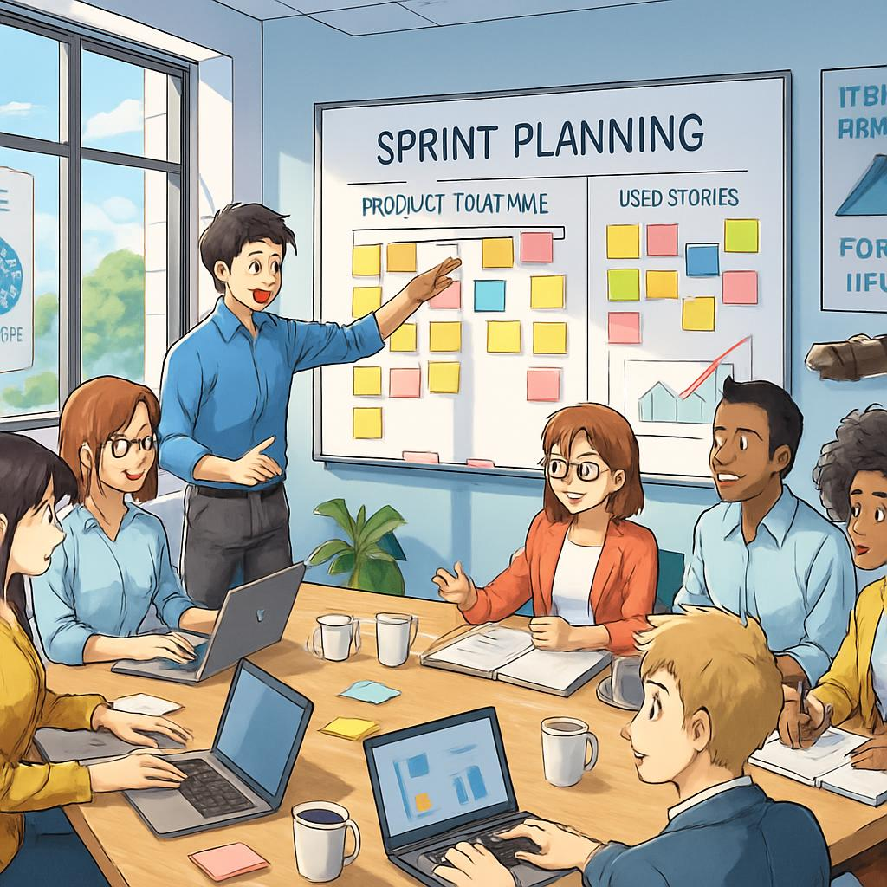
1. Product Owner
- Maximizes product value.
- Manages and orders the Product Backlog.
- Clarifies requirements and priorities.
- Helps ensure the team works on valuable features.
Example: Decides that login is more important than a profile theme.

2. Scrum Master
- Helps everyone understand and follow Scrum.
- Coaches the team in Scrum practices.
- Helps address impediments.
- Supports effective Scrum events.
Example: Helps resolve a blocker caused by an unavailable test environment.
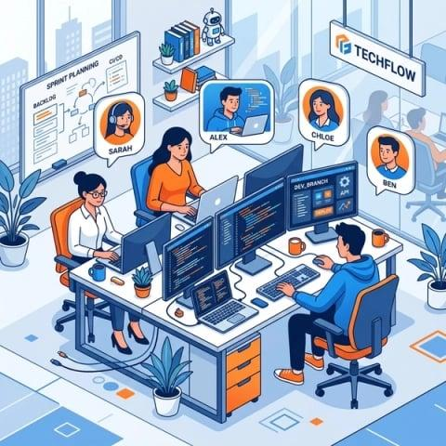
3. Developers
- Build a usable product increment.
- Plan the work needed to meet the Sprint Goal.
- Estimate and organize their work.
- Maintain quality and meet the Definition of Done.
Example: Developers implement login, write tests, and fix defects.
Common L1 traps
- Product Owner = product value and backlog ordering.
- Scrum Master = Scrum effectiveness and coaching.
- Developers = creating the product increment.
- Scrum Master is not simply the team's boss or task assigner.
- In Scrum, the Developers accountabilities can include testers; a separate tester role is not mandatory.
3. User stories and Sprints
User story
A user story describes a feature from the user's point of view.
Common format:
As a [type of user], I want [a feature], so that [a benefit].
Example:
As a customer, I want to reset my password so that I can regain access to my account.
Acceptance criteria are the conditions that must be satisfied for the story to be accepted.
For password reset, they might include:
- A registered user can request a reset.
- An invalid email produces an appropriate message.
- The reset link expires after its defined validity period.
A user story is not the same as a task: the story describes a user-valued outcome, while tasks describe work needed to deliver it.
Sprint
A Sprint is a fixed-length period in which the Scrum Team works toward a Sprint Goal and produces a usable increment that meets the Definition of Done.
- A Sprint is one month or less.
- A common duration is two weeks.
- The next Sprint begins immediately after the previous Sprint ends.
- The Sprint Goal provides a common objective.
Example: During a two-week Sprint, the team aims to deliver secure login and password reset.
4. Scrum events and meetings
1. Sprint Planning
When: At the beginning of a Sprint.
Purpose: Decide why the Sprint is valuable, what can be done, and how the work will be accomplished.
Participants: The Scrum Team.
Output: Sprint Goal and Sprint Backlog.
2. Daily Scrum / Daily Stand-up
When: Every working day during the Sprint.
Time-box: 15 minutes.
Purpose: Developers inspect progress toward the Sprint Goal and adapt their plan.
It is not merely a status report to a manager. The Developers use it to coordinate and identify problems.
3. Sprint Review
When: Near the end of the Sprint.
Purpose: Inspect the outcome with stakeholders and discuss feedback and what to do next.
Example: Demonstrate the new login feature and collect feedback.
4. Sprint Retrospective
When: After the Sprint Review and before the next Sprint Planning.
Purpose: Discuss how the team worked and identify improvements to quality and effectiveness.
Example: The team agrees to prepare test data earlier in the next Sprint.
Sprint Review vs Retrospective
Sprint Review | Sprint Retrospective
Focuses on the product and its outcome | Focuses on the team and its way of working
Includes stakeholder feedback | Focuses on process and quality improvements
Helps decide what product work comes next | Helps decide how the team can work better
Release planning vs Sprint planning
- Release planning: Forecasts which features may be delivered in a release and approximately when. Exact practices vary by organization; release planning is not a separate mandatory Scrum event.
- Sprint Planning: Plans the work for the upcoming Sprint and establishes its goal.
Scrum does not require a separate fixed release cycle. A usable increment can be released whenever appropriate.
5. Scrum artifacts and backlogs
A backlog is an ordered list of work that may need to be done.
Product Backlog
The ordered list of everything known to be needed to improve the product.
Owned/accountable for ordering: Product Owner.
Example: Login, search, cart, payment, order history.
Sprint Backlog
The Sprint Goal, the Product Backlog items selected for the Sprint, and the plan for delivering them.
Created and adapted by: Developers, collaboratively with the Scrum Team during Sprint Planning.
Example: For the login Sprint — implement login, validate credentials, automate tests.
Impediment backlog
A practical list teams sometimes use to track blockers, such as an unavailable test server or missing access permissions.
Important: It is not one of the three official Scrum artifacts. The Scrum Master helps the team address impediments.
Official Scrum artifacts and their commitments
This is a useful assessment detail.
Artifact | Commitment
Product Backlog | Product Goal
Sprint Backlog | Sprint Goal
Increment | Definition of Done
The Increment is the usable, integrated product work completed so far that meets the Definition of Done. A team can produce more than one increment during a Sprint.
6. Burn-down chart and velocity
Burn-down chart
A burn-down chart shows how much work remains over time.
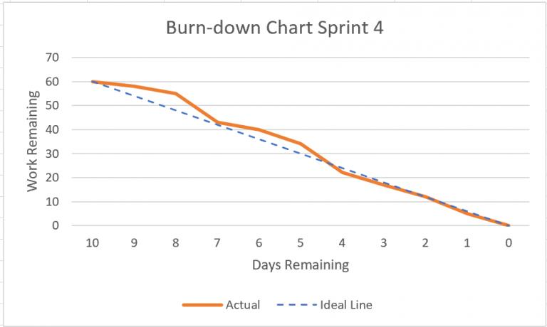
scrum.nl
- Horizontal axis (X-axis): Time, usually Sprint days.
- Vertical axis (Y-axis): Remaining work.
- A downward trend generally means work is being completed.
- If actual remaining work is above the ideal line, the team may be behind its original plan.
Example: A Sprint starts with 40 hours of estimated work. At the end of Day 1, 34 hours remain; the team has completed an estimated 6 hours of work.
A burn-down chart tracks remaining work, not the number of defects alone.
Velocity
Velocity is the amount of work a team completes in a Sprint, often measured in story points.
Example:
Sprint | Completed story points
Sprint 1 | 20
Sprint 2 | 24
Sprint 3 | 22
Average velocity:
\[ \frac{20+24+22}{3}=22 \]
The average is 22 story points per Sprint.
Velocity helps the team forecast future work based on its own history. It is not a productivity score for comparing teams. Story points are team-relative estimates, so different teams' points are not directly comparable.
Burn-down vs velocity
Burn-down chart | Velocity
Shows remaining work over time | Shows work completed per Sprint
Helps monitor progress during a Sprint | Helps forecast future capacity
Often uses hours, tasks, or points | Often uses story points
7. Definition of Done (DoD)
The Definition of Done is a shared description of the quality measures that must be met for an Increment to be considered complete.
Example for a login feature:
- Code is implemented and reviewed.
- Required unit and integration tests pass.
- Relevant automation tests pass.
- No unresolved defects that violate the agreed quality criteria remain.
- Required documentation is updated.
- The feature is integrated and meets applicable security requirements.
The exact checklist depends on the product and organization.
Definition of Done vs acceptance criteria
- Acceptance criteria: Conditions specific to a particular user story.
- Definition of Done: Shared quality standard for completed work.
A story may satisfy its acceptance criteria but still not be Done if it fails the team's Definition of Done.
8. Splitting user stories into tasks
A user story can be too large to complete within a Sprint. The team breaks it into smaller tasks.
Example story: As a customer, I want to log in securely.
Possible tasks
Task 1: Build the login form
Username/email and password fields
Task 2: Implement authentication
Validate credentials securely
Task 3: Handle error messages
Invalid credentials and required fields
Task 4: Test the feature
Positive, negative, and automation tests
Guidelines for splitting tasks
- Make tasks small enough to track and manage.
- Use clear descriptions and completion conditions.
- Identify dependencies and blockers.
- Include testing and integration work.
- Avoid splitting only by department if it prevents collaboration.
- Keep the user story focused on user value; tasks describe the work.
Why split stories into tasks? To improve visibility, coordination, estimation of effort, and progress tracking.
9. Scrum task board
A task board visually shows the status of work. A simple example is:
To Do
Build login form
Prepare test data
In Progress
Implement authentication
Done
Review requirements
Illustrative task board. Actual boards may have additional columns, such as Code Review or Testing.
A task moves across the board as its status changes. The board provides transparency and helps the team see bottlenecks.
A Scrum task board is a common practice, but Scrum does not mandate a particular board design or tool.
10. Planning Poker®, story points, and estimation
What is Planning Poker?
Planning Poker is a collaborative technique used by Agile teams to estimate the relative effort or complexity of user stories.
Team members estimate independently, reveal their estimates together, discuss differences, and estimate again if needed.
Steps in Planning Poker
- Product Owner explains the story and its acceptance criteria.
- Team members ask questions and clarify requirements.
- Each member privately selects an estimate, often using numbered cards.
- Everyone reveals their estimates at the same time.
- If estimates differ, members explain their reasoning, especially the highest and lowest estimates.
- The team discusses assumptions and votes again until it reaches a useful estimate or agrees how to proceed.
Example:
- Developer A estimates 3 points.
- Developer B estimates 5 points.
- Developer C estimates 8 points.
The team discusses why the estimates differ. Perhaps one member noticed extra testing or a dependency. They clarify the story and vote again.
The purpose is to share understanding, not to force everyone to agree with the most senior person.
What are story points?
Story points are a relative estimate of the effort involved in completing a user story. Teams commonly consider:
- Effort: How much work is involved?
- Complexity: How difficult is the work?
- Uncertainty or risk: How much is unknown?
Story points are not the same as hours or days.
Example: If a team estimates a simple button change at 1 point, a more complex payment integration might be 8 points. These are only illustrative values; every team establishes its own scale.
Fibonacci-style estimation scale
A commonly used scale is:
1
2
3
5
8
13
21
The gaps grow as estimates increase, reflecting greater uncertainty for larger work items.
- 1–2: Relatively small or simple.
- 3–5: Moderate work.
- 8–13: Larger or more uncertain.
- 21: May be too large to estimate reliably; consider splitting the story.
These descriptions are relative, not universal rules. Planning Poker does not require the Fibonacci sequence; teams can use other scales.
Other estimation techniques
Technique | Simple meaning
Expert judgment | Experienced people estimate the work
Analogy-based estimation | Compare with similar work completed before
Three-point estimation | Use optimistic, most likely, and pessimistic estimates
Planning Poker | Team members estimate collaboratively using cards
T-shirt sizing | Categorize work as XS, S, M, L, XL
Historical data | Use past results to inform future estimates
Three-point estimation commonly uses this PERT formula:
\[ E=\frac{O+4M+P}{6} \]
Where:
- \(O\) = optimistic estimate
- \(M\) = most likely estimate
- \(P\) = pessimistic estimate
Example: \(O=2,\ M=5,\ P=8\).
\[ E=\frac{2+4(5)+8}{6}=5 \]
The estimated effort is 5 units, assuming all three inputs use the same unit.
Planning Poker vs Three-point estimation
Planning Poker is a collaborative team estimation technique often used for story points. Three-point estimation is a calculation technique that combines three estimates into a weighted average.
11. Quick revision: release and Sprint planning
Topic | Remember this
Release planning | Forecast delivery of product features and release timing
Sprint Planning | Set the Sprint Goal and plan the Sprint work
Daily Scrum | 15-minute event for Developers to inspect progress and adapt their plan
Sprint Review | Inspect the product outcome and gather feedback
Sprint Retrospective | Improve the team's way of working
Product Backlog | Ordered product work
Sprint Backlog | Sprint Goal, selected items, and delivery plan
Impediment backlog | Optional list of blockers, not an official Scrum artifact
Burn-down chart | Remaining work over time
Velocity | Work completed per Sprint, often in story points
Definition of Done | Shared quality standard for a completed Increment
Planning Poker | Estimate together, discuss differences, and re-estimate

Agile Practices – XP, Lean, Kanban & Agile Testing
These notes are designed for your Capgemini L1 assessment. I'll explain each topic in simple language, with examples, important differences, and practice questions.
1. Extreme Programming (XP)
Extreme Programming (XP) is an Agile software development method that emphasizes high-quality code, frequent feedback, close collaboration, and adapting to changing requirements.
XP is especially useful when requirements change frequently and software needs to be delivered in small releases.
XP principles
- Rapid feedback: Get feedback early and often.
- Simplicity: Build only what is needed now.
- Incremental change: Make small changes rather than large risky ones.
- Embrace change: Adapt when requirements change.
- Quality work: Maintain strong engineering practices.
Important XP practices

1. Pair programming
Two programmers work together at one workstation. One writes code (driver) while the other reviews and thinks ahead (navigator). They can switch roles.
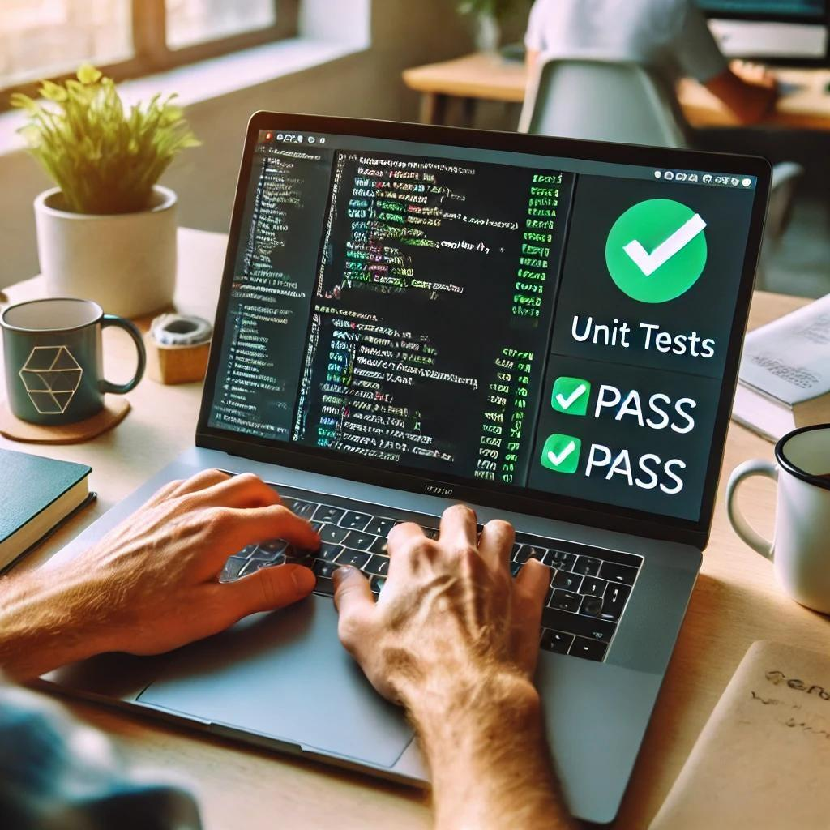
2. Test-Driven Development (TDD)
Write a test first, write the minimum code to pass it, then improve the code. This is commonly summarized as Red → Green → Refactor.

3. Continuous integration
Integrate code changes frequently and run automated checks to detect problems early.

4. Refactoring
Improve the internal structure of code without changing its external behavior.
Other XP practices include:
- Small releases: Deliver working software frequently.
- Collective code ownership: Team members can improve any part of the code.
- Coding standards: Follow shared coding conventions.
- Simple design: Avoid unnecessary complexity.
- On-site customer/customer representative: Get frequent business feedback.
- Sustainable pace: Avoid relying on constant overtime.
- Acceptance testing: Check whether features satisfy customer needs.
XP rules and key terms
Term | Simple meaning
User story | A short description of a user's need
Iteration | A short development cycle
Pair programming | Two programmers collaborate on code
TDD | Write tests before production code
Refactoring | Improve code structure without changing behavior
Continuous integration | Integrate and test code changes frequently
Small release | Deliver working software in small increments
Collective ownership | The team shares responsibility for code
Assessment tip: XP is known for engineering practices such as pair programming, TDD, refactoring, and continuous integration. Scrum is known for its framework of roles/accountabilities, events, and artifacts.
2. Lean Software Development
Lean software development focuses on delivering customer value while reducing waste.
The central idea is: Do what adds value, reduce unnecessary work, and improve continuously.
The seven commonly taught Lean principles
1. Eliminate waste
Remove activities that do not add value, such as unnecessary waiting or duplicate work.
2. Build quality in
Prevent defects early instead of relying only on final-stage testing.
3. Create knowledge
Learn through experiments, feedback, and shared understanding.
4. Defer commitment
Keep options open until enough information is available to make a sound decision.
5. Deliver fast
Deliver useful software quickly to get feedback.
6. Respect people
Trust the team, encourage collaboration, and support people's skills.
7. Optimize the whole
Improve the complete delivery process, not just one team's local performance.
Examples of waste in software development
- Waiting for access to a test environment.
- Building features nobody needs.
- Repeating manual tests unnecessarily.
- Fixing defects that could have been prevented earlier.
- Passing work between teams with long delays.
- Maintaining excessive documentation that provides little value.
Lean does not mean eliminating all documentation or testing. It means avoiding waste while preserving the quality and information the product needs.
XP vs Lean
XP | Lean
Emphasizes engineering practices | Emphasizes value and waste reduction
TDD, pair programming, refactoring | Flow, learning, quality, continuous improvement
Strong focus on code quality and feedback | Strong focus on the whole delivery system
3. What is Kanban?
Kanban is a method for managing work visually, improving workflow, and limiting work in progress.
A Kanban board shows tasks moving through different stages.
To Do
Login page
Search feature
In Progress
Cart validation
Testing
Payment checks
Done
Registration
Illustrative Kanban board. Tasks move from left to right as work progresses.
Key Kanban concepts
- Visualize workflow: Make the status of every task visible.
- Limit WIP (Work in Progress): Restrict how many tasks can be worked on simultaneously.
- Manage flow: Reduce delays and help tasks move smoothly to completion.
- Make policies explicit: Clearly define what is required to move a task between columns.
- Use feedback loops: Review workflow regularly and identify bottlenecks.
- Improve collaboratively: Make continuous, incremental improvements.
What is a WIP limit?
A WIP limit restricts how many items can be in a particular stage at once.
Example: If the Testing column has a WIP limit of 3 and already contains 3 tasks, the team should generally help finish existing testing work before moving another task into that column.
Why? It prevents too much unfinished work from piling up and exposes bottlenecks.
Scrum vs Kanban vs XP
Feature | Scrum | Kanban | XP
Main focus | Delivering value in Sprints | Smooth flow of work | High-quality software engineering
Work organization | Fixed-length Sprints | Continuous flow | Iterations and small releases are common
WIP limits | Not a required Scrum rule | A key practice | Not its defining practice
Typical emphasis | Events and artifacts | Board and workflow | TDD, pair programming, refactoring
Remember: Kanban does not require fixed-length Sprints. Scrum does. XP emphasizes engineering discipline.
4. What is Agile Testing?
Agile testing is testing performed continuously throughout Agile development, with frequent collaboration between testers, developers, and business representatives.
Testing is not left until development is completely finished.
Example: While developers build a shopping cart, testers clarify the requirements, prepare test cases, check the feature, automate suitable tests, and provide feedback during the same iteration.
Traditional testing vs Agile testing
Traditional approach | Agile approach
Testing may happen after development | Testing happens throughout development
Requirements are often defined early | Requirements can evolve through feedback
Larger testing phase or handoff | Frequent collaboration between developers and testers
Feedback may arrive late | Feedback arrives regularly
Testing can rely heavily on end-stage execution | Continuous testing and automation are encouraged
Traditional projects can also test early, and Agile projects can still have formal test plans. The table describes common tendencies, not absolute rules.
Agile testing mindset shifts
- From “testing is only the tester's job” to quality is everyone's responsibility.
- From “find defects at the end” to prevent and detect defects early.
- From “follow the original plan regardless” to adapt based on feedback.
- From “test everything manually” to combine manual testing with suitable automation.
- From “finish my task” to help deliver a working, valuable feature.
5. Tester and Test Manager roles in Agile
Agile tester
An Agile tester:
- Clarifies user stories and acceptance criteria.
- Identifies risks and test scenarios early.
- Performs exploratory, functional, and other appropriate testing.
- Creates and maintains automation where useful.
- Collaborates with developers to prevent defects.
- Reports risks and feedback quickly.
Test Manager
Where a separate Test Manager role exists, responsibilities may include:
- Coordinating testing across teams or projects.
- Helping plan resources, schedules, and test environments.
- Monitoring risks, coverage, defects, and quality metrics.
- Supporting test strategy and reporting.
- Helping remove organizational obstacles.
Important: Agile does not require a separate Test Manager. In some Agile teams, testing coordination and planning responsibilities are shared across the team, while a Test Manager may support larger programs or multiple teams.
Who is responsible for quality?
The whole team. Testers bring specialist testing skills, developers help prevent and fix defects, the Product Owner clarifies value and requirements, and the Scrum Master helps the team work effectively within Scrum.
6. What is Iteration 0?
Iteration 0 is an informal term used by some Agile teams for an initial preparation period before regular feature-delivery iterations begin.
It is not a mandatory Scrum event or a universal Agile requirement.
Typical activities include:
- Setting up development and test environments.
- Creating the initial backlog.
- Agreeing on coding and testing standards.
- Setting up source control and continuous integration.
- Preparing test data and automation frameworks.
- Understanding architecture, risks, and initial requirements.
Example: Before testing an e-commerce application, the team sets up Playwright, configures browsers, prepares test accounts, and creates the first automated test.
Key point: Iteration 0 should enable delivery; it should not become a long phase that delays working software unnecessarily.
7. User Story Perspective Testing
A user story describes a feature from the user's point of view. Testing should consider whether the feature works for different users, situations, and risks.
Example user story:
As a customer, I want to reset my password so that I can regain access to my account.
A tester can examine it from several perspectives:
Perspective | Example tests
Normal user | Registered user requests a reset
Invalid input | Unregistered email is entered
Security | Reset link cannot be reused after expiry
Usability | Instructions are clear
Error handling | Service is temporarily unavailable
Compatibility | Feature works in supported browsers
Accessibility | Form fields have appropriate labels and can be used with a keyboard
Acceptance criteria vs test cases
- Acceptance criteria define the conditions the story must satisfy.
- Test cases specify steps, inputs, and expected results to verify those conditions.
A useful tester asks: “What should happen in the normal case, what could go wrong, and what would make this feature safe and easy to use?”
8. Agile Testing Quadrants
The Agile Testing Quadrants model helps teams organize different kinds of testing according to their purpose. It distinguishes tests that support the team from tests that evaluate the product.
The quadrants are often described using two dimensions:
- Business-facing vs technology-facing
- Supporting the team vs critiquing/evaluating the product
Q2
Business-facing, supports the team
Functional tests, examples, acceptance criteria, prototypes
Often automated, but not always
Q3
Business-facing, critiques the product
Exploratory, usability, user acceptance testing
Often manual and human-centered
Q1
Technology-facing, supports the team
Unit tests, component tests, automated checks
Usually automated
Q4
Technology-facing, critiques the product
Performance, load, security, reliability testing
Often uses specialized tools
The quadrant layout is a learning aid. Actual tests can overlap, and the model does not prescribe one fixed tool for each quadrant.
Quadrant 1 (Q1): Technology-facing, supports the team
Goal: Verify technical correctness early.
Typical tests:
- Unit testing
- Component testing
- Low-level integration testing
- Automated developer tests
Example: Check that a password-validation function rejects an invalid password.
Typical toolkit: JUnit, TestNG, Jest, or other unit-testing frameworks.
Quadrant 2 (Q2): Business-facing, supports the team
Goal: Check that the software meets business requirements and agreed examples.
Typical tests:
- Functional tests
- Acceptance tests
- Tests derived from user stories and acceptance criteria
- Examples and prototypes
Example: Confirm that a registered customer can successfully log in with valid credentials.
Typical toolkit: Cucumber-style executable specifications, acceptance-testing tools, and Playwright for browser-based functional tests.
Quadrant 3 (Q3): Business-facing, critiques the product
Goal: Evaluate how well the product works for real users and discover issues that scripted checks might miss.
Typical tests:
- Exploratory testing
- Usability testing
- User acceptance testing
- User feedback and scenario-based testing
Example: Ask a user to reset a password and observe whether the instructions are confusing.
Typical toolkit: Exploratory test charters, checklists, usability sessions, and browser developer tools.
Quadrant 4 (Q4): Technology-facing, critiques the product
Goal: Evaluate non-functional characteristics and technical risks.
Typical tests:
- Performance and load testing
- Stress testing
- Security testing
- Reliability and scalability testing
Example: Check whether the website can handle a large number of simultaneous users.
Typical toolkit: JMeter or k6 for performance testing, plus appropriate security-testing tools.
Quadrant memory trick
- Q1: Technical correctness
- Q2: Business requirements
- Q3: User experience
- Q4: Performance and other technical qualities
Which quadrant does Playwright belong to?
Playwright is commonly used for Q2 automated functional/acceptance testing. It can also support some Q3 exploratory work and selected end-to-end checks. The quadrant depends on the purpose of the test, not simply the tool being used.
For example, an automated test that checks a business requirement belongs naturally in Q2, while manually exploring whether a workflow is confusing fits Q3.
9. Test Planning in Agile
Agile teams plan testing continuously rather than assuming that all testing decisions can be finalized at the beginning.
What should an Agile test plan cover?
- Scope: What features and risks need testing?
- Approach: Manual, automated, exploratory, or a combination?
- Acceptance criteria: What must each story satisfy?
- Test data: What inputs and accounts are needed?
- Environment: Which browsers, devices, services, and configurations must be available?
- Automation: Which tests should be automated, and at what level?
- Responsibilities: Who will collaborate on each activity?
- Risks and dependencies: What could block testing?
- Entry and exit conditions: When can testing begin, and what indicates sufficient completion?
- Reporting: How will defects, progress, and quality risks be communicated?
Agile testing workflow
- Before an iteration: Refine stories, clarify acceptance criteria, identify risks, and prepare the test approach.
- During planning: Estimate testing effort, identify dependencies, and include test work in the team's plan.
- During development: Test early, collaborate with developers, automate suitable checks, and report defects.
- Before completion: Verify acceptance criteria and the Definition of Done, including relevant regression checks.
- After feedback: Discuss issues and improvements, then adapt testing in the next iteration.
Test planning in Agile vs traditional projects
Traditional-style planning | Agile-style planning
A detailed plan may be established early | Planning is revisited as requirements evolve
Testing may be organized around a later test phase | Testing is integrated into ongoing development
Changes can require formal plan updates | The team adapts plans frequently while managing risks
Feedback may arrive at milestones | Feedback is gathered throughout iterations
Agile testing still requires planning, documentation, risk management, and reporting. The difference is that these activities are adapted continuously.
Test planning example: E-commerce login
Activity | Example
Scope | Login, logout, invalid credentials
Positive tests | Valid customer can log in
Negative tests | Incorrect password is rejected
Security | Authentication and session behavior are checked
Automation | Repeatable browser tests are written in Playwright
Regression | Existing login behavior is rechecked after changes
Completion | Acceptance criteria and Definition of Done are satisfied
Entry criteria vs exit criteria
- Entry criteria: Conditions needed before a test activity starts. Example: the test environment is ready.
- Exit criteria: Conditions used to decide whether a test activity has reached an acceptable stopping point. Example: planned tests are executed and remaining risks are reported.
In Agile, criteria should be practical and appropriate to the story, iteration, or release being tested.
Defect Reporting and JIRA — Capgemini L1 Notes
This syllabus has three main areas: defect reporting, defect tracking tools, and hands-on JIRA. I'll explain the concepts in simple language, use software-testing examples, and highlight likely MCQ distinctions. The practice questions are based on your syllabus, not confirmed questions from Capgemini's actual assessment.
Part 1: Defect Reporting
1. What is software quality?
Software quality means how well software satisfies its requirements, works reliably, and meets user needs.
For example, a banking application should:
- Allow customers to log in securely.
- Display the correct account balance.
- Transfer money accurately.
- Work reliably and protect customer data.
- Be usable and accessible.
Software can appear to work correctly but still have quality problems, such as slow performance, poor usability, or security weaknesses.
2. What is a defect?
A defect (also called a bug or fault in common usage) is a flaw in a software product or related work product that may cause it to fail to meet requirements or expectations.
Example: A banking app transfers ₹1,000 but displays ₹10,000 as transferred. This is a defect.
Error vs defect vs failure
Term | Meaning | Example
Error | A human mistake | A developer writes the wrong calculation
Defect | A flaw introduced into a work product | The transfer calculation uses the wrong amount
Failure | Incorrect behavior when the software runs | The app transfers or displays the wrong amount
Memory trick: Human mistake → defect in the product → possible failure during execution.
A defect does not always cause a visible failure; the relevant code or condition may never be executed.
3. Why find defects?
Finding defects helps teams:
- Protect users and their data.
- Prevent financial loss.
- Improve reliability and performance.
- Meet requirements and legal obligations.
- Reduce the cost of fixing issues later.
- Maintain customer trust and business reputation.
Impact of defects
User impact
Users may be unable to complete tasks, lose work, or receive incorrect information.
Business impact
Revenue loss, refunds, support costs, and reputational damage.
Security and safety impact
Exposure of sensitive information, unauthorized access, or unsafe system behavior.
Legal and compliance impact
Regulatory penalties, contractual disputes, or liability if the product violates applicable obligations.
Legal implications
Defects may have legal consequences when software fails to comply with applicable laws, regulations, contracts, privacy requirements, or safety standards.
For example, a financial application that mishandles customer information could trigger regulatory and contractual consequences.
Assessment point: Legal implications depend on the product, jurisdiction, contracts, and nature of the defect. Not every software defect automatically creates legal liability.
4. What is a defect report?
A defect report is a documented record of a problem found in software, containing enough information for the team to reproduce, investigate, prioritize, and resolve it.
A good defect report answers five questions:
- What went wrong?
- Where did it happen?
- How can someone reproduce it?
- What should have happened?
- How serious is it?
Why is defect reporting necessary?
- Communicates problems clearly between testers and developers.
- Prevents defects from being forgotten or duplicated.
- Supports prioritization and assignment.
- Records the defect's history and resolution.
- Helps analyze recurring problems and product quality.
- Provides evidence for testing progress and release decisions.
5. Defect report template
Here is a practical example based on an online banking application.
Sample defect report
Defect ID: BANK-142
High severity
Incorrect balance displayed after transfer
Environment: Test environment · Chrome · Windows
Preconditions
Customer is logged in and has a sufficient account balance.
Steps to reproduce
- Open the transfer page.
- Enter ₹1,000 as the transfer amount.
- Complete the transfer.
- Check the confirmation screen.
Expected result
The confirmation screen displays ₹1,000 as the transfer amount.
Actual result
The confirmation screen displays ₹10,000.
Reproducibility
Occurs consistently in the reported test environment.
Priority
High — requires prompt investigation based on business impact.
Attachments
Screenshot, relevant logs, and transaction reference from the test environment.
This example illustrates the structure of a report; it is not an actual JIRA issue.
Important defect report attributes
Attribute | Purpose
Defect ID | Unique identifier
Summary/title | Short description of the problem
Description | Additional details and context
Steps to reproduce | Exact steps to trigger the issue
Expected result | Correct behavior
Actual result | Observed incorrect behavior
Environment | Browser, OS, device, build, test environment
Severity | Degree of impact
Priority | Urgency for fixing
Reporter | Person who raised the issue
Assignee | Person/team responsible for handling it
Status | Current workflow state
Attachments | Screenshots, logs, videos, relevant evidence
Version/build | Version where the defect was observed
Resolution | Outcome, such as fixed or duplicate
Not every organization uses all these fields, and exact names depend on the tracking tool's configuration.
6. Severity vs priority
This is one of the most important assessment topics.
- Severity: How seriously the defect affects the system.
- Priority: How urgently the defect should be fixed.
Example | Severity | Priority | Reason
Banking app allows unauthorized access | Critical | High | Serious security risk
Homepage logo slightly misaligned before a major launch | Low | High | Time-sensitive business visibility
Rare crash in an obsolete internal report | High impact when triggered | Low or medium | Depends on usage and business risk
Typo on a rarely used help page | Low | Low | Small impact and low urgency
These are illustrative. Real severity and priority assignments depend on organizational rules, customer impact, workarounds, and release timing.
Memory trick: Severity = how bad? Priority = how soon?
Severity and priority are related, but they are not the same. A high-severity issue is often high priority, though business context can change the urgency.
7. Defect life-cycle workflow
A defect life cycle is the sequence of statuses through which a defect moves from reporting to closure.
1. New
Tester reports the defect
2. Assigned
Defect is assigned for investigation
3. Open / In Progress
Developer investigates and works on a fix
4. Fixed / Resolved
A fix is provided
5. Retest
Tester verifies the fix
6. Closed
Tester confirms the issue is resolved
If the defect still occurs during retesting, it may be reopened or returned to the development team. Exact statuses depend on the workflow.
Other possible defect statuses
- Rejected / Not a bug: Report does not represent a valid defect.
- Duplicate: The same problem has already been reported.
- Deferred: The team decides to fix it later.
- Cannot reproduce: The team cannot reproduce the reported behavior using the available information.
- Reopened: The problem remains after the fix or returns.
Defect workflow enhancement
Organizations may improve their workflow by adding:
- A triage step to confirm severity and priority.
- A review step before closing.
- A verification status for testing.
- A deferred state with a reason and review date.
- Clear ownership and required fields for each transition.
A good workflow should make responsibility and status clear without creating unnecessary delays.
8. What makes a defective defect report?
A defective defect report is a report that is incomplete, unclear, inaccurate, or difficult to reproduce.
Common problems include:
- Vague title: “App not working.”
- Missing steps to reproduce.
- Expected result not mentioned.
- Actual result is unclear.
- No environment or build information.
- Missing screenshots or relevant logs.
- Multiple unrelated issues in one report.
- Incorrect severity or priority.
- Duplicate reports without linking to the original.
How to improve it
Instead of writing:
Payment is broken.
Write:
Payment confirmation shows “Failed” after a successful test transaction in Chrome on build 2.4. Steps, expected behavior, actual behavior, timestamp, and sanitized logs are attached.
A good report should be clear, specific, reproducible, factual, and concise.
Never include real passwords, payment-card details, or unnecessary personal information in a defect report.
9. Defect report users
Different people use defect reports for different purposes.
User | Why they need the report
Tester | Reproduce the issue and verify the fix
Developer | Investigate the cause and implement a fix
Test Lead / Test Manager | Monitor defects, risks, and progress
Product Owner / Business Analyst | Understand business impact and make priority decisions
Project Manager | Monitor delivery risk and release readiness
Support team | Understand known issues and workarounds
Auditor / Compliance team | Review relevant evidence and process records
10. Defect management: logging, tracking, and analysis
Defect management is the process of recording, prioritizing, tracking, resolving, and analyzing defects.
- Logging: Create the defect record with a clear summary, reproduction steps, expected/actual results, and evidence.
- Triage: Review validity, severity, priority, ownership, and whether it duplicates another issue.
- Tracking: Monitor its status, assignee, comments, and history.
- Fixing: The development team investigates and resolves the issue.
- Verification: Testing confirms whether the fix works and whether relevant regression tests pass.
- Closure and analysis: Close the issue when appropriate and review patterns to prevent recurrence.
Defect analysis metrics
- Defect density: Number of defects relative to a defined size measure, such as code size or function points.
- Defect leakage: Defects discovered after a testing phase or release that were missed earlier.
- Defect rejection rate: Proportion of reported defects that are rejected as invalid, duplicate, or otherwise not accepted, depending on the metric definition.
- Open defect count: Number of unresolved defects.
- Defect aging: How long defects have remained open.
- Defect distribution: Defects grouped by module, severity, type, or source.
Metrics need consistent definitions. For example, defect leakage may be measured between testing phases or from testing into production, depending on the organization's reporting standard.
11. The most severe defect
The most severe defect depends on the system and context. In general, defects that cause serious safety hazards, unauthorized access, sensitive-data exposure, or major financial loss deserve urgent attention.
Examples:
- A banking system exposes customers' confidential account information.
- A payment system charges customers incorrectly on a large scale.
- A medical system produces a dangerous incorrect result.
- A security weakness allows unauthorized users to gain privileged access.
Assessment point: A cosmetic issue is usually less severe than a security or safety defect, but the final severity classification should follow the team's defined criteria and risk assessment.
Part 2: Defect Tracking Tools
12. What is a defect tracking tool?
A defect tracking tool records defects and helps teams manage them throughout their life cycle.
Common capabilities include:
- Create and assign defects.
- Set severity, priority, and status.
- Attach screenshots and logs.
- Track comments and changes.
- Search, filter, and report on defects.
- Integrate with test management and development tools.
Tools in your syllabus
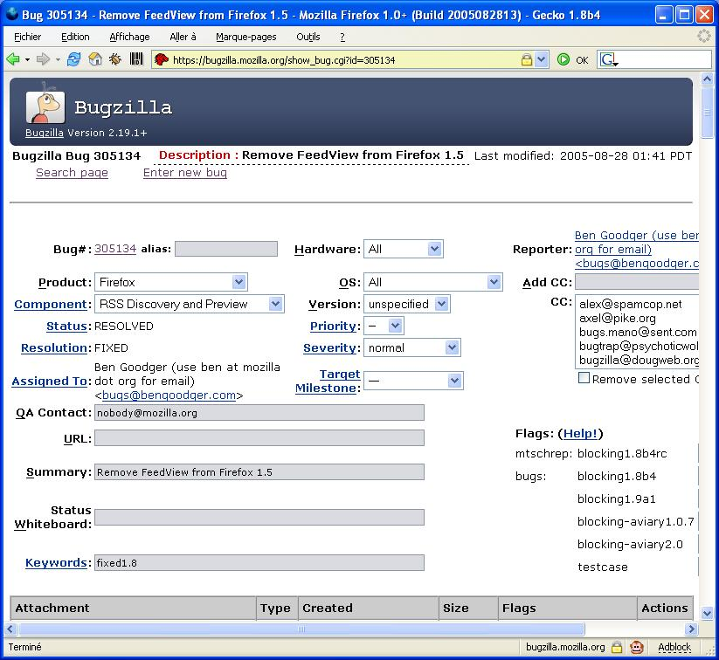
Bugzilla
An open-source bug-tracking system used to report, assign, search, and manage defects. It supports fields such as product, component, version, severity, priority, and status.
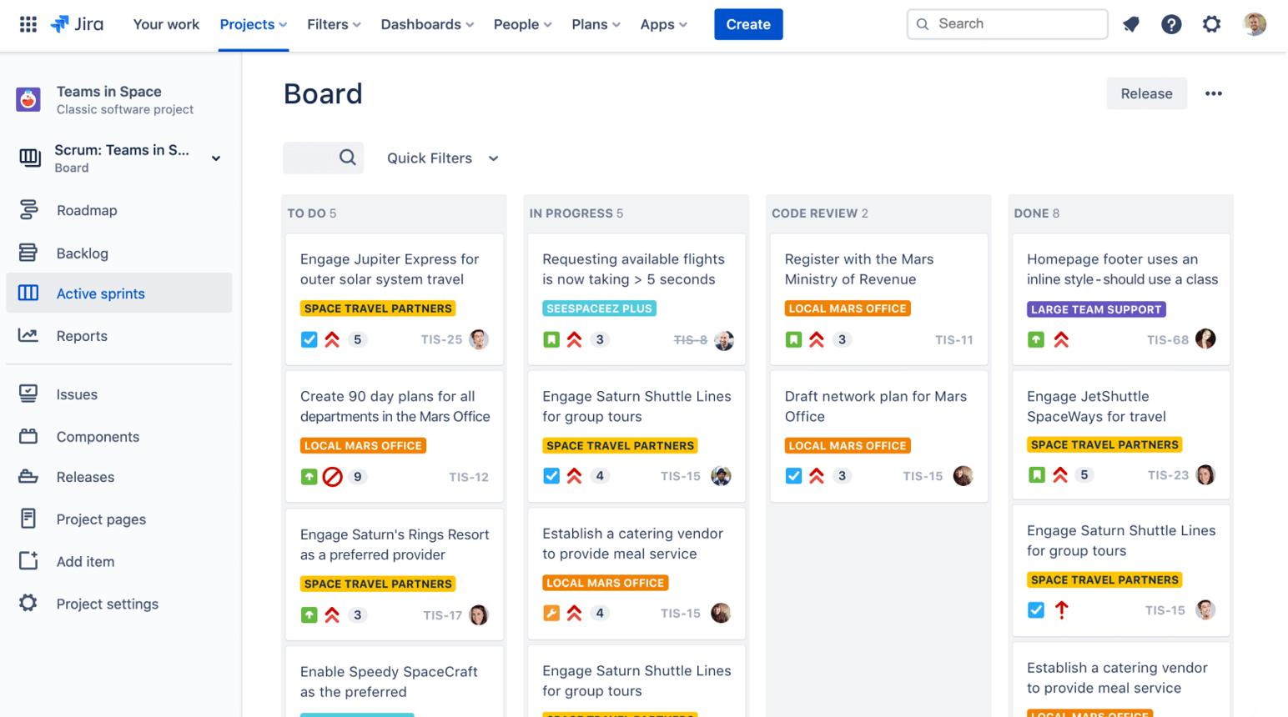
JIRA / Jira
An issue-tracking and work-management platform. Jira Software is commonly used by Agile software teams to manage projects, backlogs, Sprints, bugs, stories, and reports.
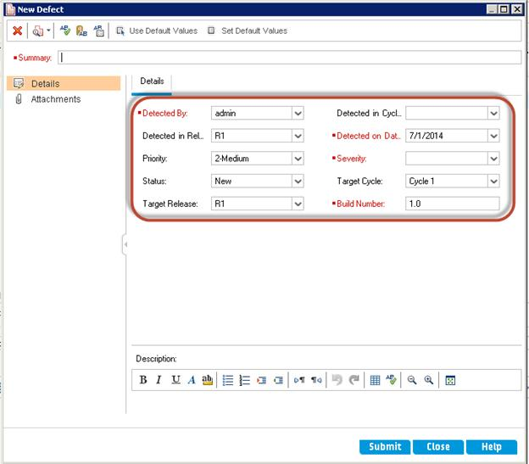
HP ALM / Quality Center
A traditional enterprise application lifecycle and quality management tool. It supports requirements, test planning, test execution, and defect management. The product is now associated with OpenText; names and interfaces vary by version.
Quick comparison
Tool | Main association
Bugzilla | Open-source bug tracking
Jira Software | Issues, Agile boards, backlogs, Sprints, reports
HP ALM / Quality Center | Enterprise requirements and test management
The user interface and available features depend on the product edition, configuration, and version.
Part 3: Introduction to Jira
13. What is Jira?
Jira is a tool used to create, organize, assign, track, and report work items.
For a software team, Jira can help manage:
- Bugs and defects.
- User stories and tasks.
- Epics and larger initiatives.
- Product and Sprint backlogs.
- Workflows and assignments.
- Dashboards and Agile reports.
A Jira work item is commonly called an issue. In newer Jira interfaces, Atlassian increasingly uses the term work item, while many projects and training materials still use issue.
14. Basic Jira concepts
Concept | Simple meaning | Example
Project | Collection of related work | Online Banking
Issue | A tracked work item | Fix login failure
Epic | Larger body of work | Customer authentication
Story | User-valued feature | Customer can reset password
Task | Work to be completed | Configure test environment
Bug | Reported software defect | Incorrect balance displayed
Sub-task | Smaller part of a parent issue | Add validation tests
Component | Logical area of a project | Login, Payments
Version / Release | A product version or release grouping | Version 2.4
Workflow | Statuses and transitions for work | Open → In Progress → Done
Sprint | Fixed-length Scrum period | Two-week Sprint
Backlog | Ordered list of work items | Features waiting for development
Epic vs story vs task vs bug
Epic
Customer authentication
A large area of work.
Story
As a customer, I want to reset my password.
Task
Configure the password-reset test environment.
Bug
Reset link remains valid after expiry.
Illustrative grouping. Jira permits different issue relationships depending on project configuration; not every task or bug must belong to a story.
15. Jira issue priority
Priority indicates how urgently an issue should be addressed, according to the project's configured priority scheme.
Typical priority labels include:
- Highest / Blocker
- High / Critical
- Medium
- Low
- Lowest
These labels are examples, not a universal Jira default. A project can customize its priority options.
Remember: Jira priority is not automatically the same as defect severity. Severity may be a separate field or team-defined convention.
16. Jira issue workflow
A workflow defines the statuses an issue can move through and the transitions allowed between them.
Example bug workflow:
To Do / Open
In Progress
Resolved / Fixed
Ready for Testing
Closed
Example workflow only. Jira workflows are configurable, so your organization's statuses may differ.
A workflow may include conditions, validators, or automated actions. For example, a team may require a resolution field before allowing an issue to be closed.
17. Jira projects and components
A project organizes related work under a common scope and configuration.
A component groups issues within a project by functional area or subsystem.
Example for an online banking project:
- Login
- Account Management
- Payments
- Statements
- Notifications
A component can help with filtering, reporting, or default assignment, depending on configuration.
What is a version in Jira?
Versions are commonly used to group work associated with a release.
For example:
- 2.1 — earlier release
- 2.2 — next release
- 3.0 — major release
Jira may distinguish between Affects Version/s (where a problem occurs) and Fix Version/s (where the issue is intended to be fixed or delivered).
18. What are sub-tasks?
A sub-task is a smaller work item created under a parent issue.
Example:
Parent task: Test password reset.
Sub-tasks:
- Verify valid reset request.
- Verify invalid email handling.
- Verify reset link expiry.
- Automate the browser test.
Sub-tasks help break down work, assign responsibilities, and track progress. They usually have a parent-child relationship with their parent issue, and project configuration controls how they are created and managed.
Part 4: Hands-on Jira — Step-by-Step
The exact buttons can differ between Jira Cloud, Data Center, and your organization's configuration. These are the general steps to understand for your course.
19. Create a Scrum project
- Log in to your organization's Jira site.
- Open Projects and select the option to create a project.
- Choose a Scrum template if available.
- Enter a project name, such as Online Banking Testing.
- Choose or confirm the project key, such as OBT.
- Create the project and open its backlog or board.
A project key is a short identifier used in issue keys. For example, OBT-12 identifies an issue in the project with key OBT.
You need the appropriate permissions to create projects.
20. Invite team members
- Open the project settings or project access area.
- Find the option to manage access or people.
- Add the relevant users or groups.
- Assign the appropriate project role or permission.
- Confirm that they can access the project.
Important: Inviting someone does not necessarily grant every permission. Access depends on Jira administration, project roles, and permission schemes.
21. Create components
For an online banking project, components could be:
- Login
- Payments
- Account Details
- Reports
Depending on the Jira project type and configuration, components are generally managed through project settings. Team-managed and company-managed projects may offer different options.
22. Create Jira issues
The usual process is to select Create, choose the project and issue type, fill the required fields, and submit.
Example: create a bug
Illustrative form, not a live Jira form.
Project
Online Banking Testing
Issue type
Bug
Summary
Incorrect balance shown after transfer
Description
Include preconditions, reproduction steps, expected result, actual result, environment, and evidence.
Priority
High
Component
Payments
The required fields depend on the project's configuration.
Create an Epic, Story, Task, and Bug
- Epic: Create a larger body of work, such as Customer Authentication.
- Story: Describe a customer feature and its acceptance criteria.
- Task: Describe work that needs to be completed.
- Bug: Document incorrect software behavior.
In some project types, you create an Epic and then link stories to it. The exact hierarchy and creation steps depend on Jira configuration.
23. Create a sub-task
- Open the parent issue.
- Select the sub-task creation action, if available.
- Enter a clear summary and description.
- Set the assignee and other required fields.
- Create the sub-task and confirm its parent relationship.
Example: Under Test password reset, create Verify reset link expiry.
24. Manage issues and issue properties
Common actions include:
- Change status through a workflow transition.
- Assign an issue.
- Change priority or component.
- Add comments and attachments.
- Link related issues.
- Create or update labels.
- Set fix versions.
- Track work and view history.
The available fields and actions depend on your permissions and project setup.
25. Import issues from a CSV file
CSV import is useful when issues are prepared in a spreadsheet.
Typical process:
- Prepare a CSV file with a header row.
- Include fields such as Summary, Issue Type, Description, Priority, and Assignee where supported.
- Open the Jira import option available to your administrator or project.
- Upload the file.
- Map CSV columns to Jira fields.
- Validate the mapping and required fields.
- Preview the data, resolve errors, and import.
Example CSV:
Summary,Issue Type,Priority,Description
Login fails with valid credentials,Bug,High,User cannot log in
Add password reset,Story,Medium,Allow customers to reset passwords
Prepare browser test environment,Task,Low,Configure test browsers
This is illustrative. Jira's accepted priority names, issue-type names, user identifiers, and import procedure can vary. Check the preview before importing, because incorrect mappings can create many unwanted issues.
26. Zephyr for test case management
Zephyr is a test management solution that integrates with Jira in supported configurations. Product editions and integrations differ.
It can help teams:
- Create and manage test cases.
- Organize test cycles or test plans.
- Link tests to Jira issues.
- Record test execution results.
- Track pass/fail status.
- Report test coverage and execution progress.
Typical workflow:
- Confirm that the organization has the appropriate Zephyr product and permissions.
- Open the relevant Jira project.
- Use the available Zephyr test-management area.
- Create a test case with steps, test data, and expected results.
- Organize tests into a cycle or plan if supported.
- Execute the test and record its result.
- Link relevant bugs to failed tests.
Zephyr configuration and navigation depend on the specific product edition; do not assume every Jira instance has the same menus.
Part 5: Jira Sprints and Reports
27. Create a Sprint in Jira
In a Scrum project, the backlog is commonly where teams organize and plan Sprints.
General steps:
- Open the Scrum project's Backlog.
- Create a Sprint.
- Add or move Product Backlog items into the Sprint.
- Refine the Sprint scope and confirm the Sprint Goal.
- Set the Sprint duration and start/end dates where required.
- Select Start Sprint when the team is ready.
Once a Sprint starts, the team tracks work on its board. Changes to scope should be managed thoughtfully while protecting the Sprint Goal.
28. Jira reports
Your syllabus mentions four important reports.
1. Epic report
Shows progress on the work associated with an Epic, helping teams understand how its related issues are progressing.
Example: Track stories associated with Customer Authentication.
Availability and exact details vary by Jira edition and project configuration.
2. Created vs Resolved Issues report
Compares the number of issues created with the number resolved during a period.
- If issues are created faster than they are resolved, the backlog may grow.
- If more issues are resolved than created, the backlog may shrink.
This report helps monitor issue trends; it does not by itself prove that product quality is improving or declining.
3. Sprint report
Summarizes what happened in a Sprint, including completed and incomplete work and scope changes where supported.
Example: Identify which stories were completed and which carried over.
4. Burn-down chart
Shows remaining work over the course of a Sprint.
Remember: A downward trend generally indicates that remaining work is decreasing. Scope changes can affect the chart.
5. Velocity chart
Compares estimated work with completed work across recent Sprints, often using story points.
It helps the team forecast future work using its own historical results. It should not be used to rank different teams.
Burn-down vs velocity chart
Burn-down | Velocity
Focuses on remaining work during a Sprint | Focuses on completed work across Sprints
Helps monitor Sprint progress | Helps forecast future capacity
Work should generally trend downward | Completed story points may vary from Sprint to Sprint
What if issues are not appearing in a report?
Check:
- Is the correct project or board selected?
- Is the issue associated with the expected Sprint or Epic?
- Is the status mapped correctly to the board columns?
- Are the relevant estimates and dates populated?
- Does your Jira edition support the report?
29. JIRA quick revision sheet
Question | Answer to remember
What is Jira used for? | Track and manage issues and work
What is a project? | A collection of related work
What is an issue? | A tracked work item
What is an Epic? | A larger body of work
What is a sub-task? | A smaller work item under a parent
What is a component? | A logical area within a project
What is a workflow? | Statuses and transitions for issues
What is a version? | A release-related grouping
What is issue priority? | Urgency of handling an issue
What does CSV import do? | Creates or imports issues from tabular data
What is Zephyr used for? | Test case and test execution management
What does Created vs Resolved show? | Issue creation and resolution trends
What does a Sprint report show? | Sprint outcome and incomplete work
What does a velocity chart show? | Completed work across Sprints
What does a burn-down chart show? | Remaining work over time

